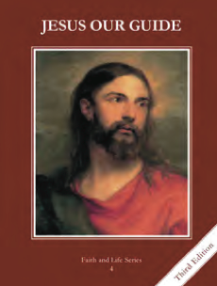
CCD GRADE 4: JESUS OUR GUIDE
Chapter 16: An Invitation to Heaven
• PREPARATION – How to Get Ready
Teacher’s Manual: pp. 192-196
Materials: powerpoint
• PROCLAMATION – Main Theme
Jesus desires us to be in Heaven with Him, but as human beings we have free will and must choose to have a relationship with Him by freely and lovingly following His commandments.
• EXPLANATION – Content of Lesson

- The soul is the spiritual part of us which never dies and enables us to live, understand, and be free.
- Review the order of creation
- Discussion questions (on slide) about how we are different from other creatures, and what the soul does.
- Free will is the soul’s power to choose to do or not do something.
- Ask questions that make them choose between two things-discuss what gives them the ability to do this.
- Define free will and discuss the difference between free will and freedom
- Discussion questions related to free will and freedom
- God gives us the gift of free will to choose to love Him and follow His Commandments.
- Ask: Why do we have free will?
- Lead discussion: if we don’t have free will, we become like robots and cannot truly love
- God wants us to obey the Ten Commandments to love Him.
- Scriptures Ex 19:5, John 14:15; John 14:23-what do these say about our free will and what we will do if we love
- How do we show love for another? By listening to and obeying them
- Discuss why God gave us the commandments—out of love, because He created us and will make us truly happy; salami in computer example from powerpoint
- The two Great Commandments are to love God with all our heart, soul, strength, and mind; and to love our neighbor as ourselves.
- Review that the commandments are divided into two sections (1-3 and 4-10); the first three tell us how to love God and the last seven show us how to love our neighbor.
• APPLICATION – Connecting it to Students
- Discussion questions in powerpoint
- Act out human and robot differences as they are given directions.
- https://youtu.be/K0M3X3_pFD4 “Good Fight” by Unspoken. No matter how difficult it is to use our free will to make right choices, God is always there with grace to support us to the end in victory.
• CELEBRATION - Conclusion
- Pray a personal group litany of “I Choose.” For example, “I choose to love my family.” “I choose to forgive my brother whenever he lies to me.” “I choose to reject self-pity.” “I choose to respond kindly to angry words.” “I choose to reject selfishness.” “I choose to be fully alive in Christ.”

