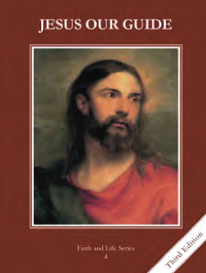
CCD GRADE 4: JESUS OUR GUIDE
Chapter 17: Road Signs along the Way
• PREPARATION – How to Get Ready

Teacher’s Manual: pp. 203-211
Materials: powerpoint
• PROCLAMATION – Main Theme

The first three commandments teach us to love God.
• EXPLANATION – Content of Lesson

- The First Commandment teaches us to worship God, not money or things.
- Review why God made us and what the first commandment is
- Brainstorm false gods of the Old Testament and false gods that we have today
- Brainstorm/discuss/act out ways that you can live the commandment and ways that we break the commandment (some examples are in the powerpoint)
- Prayer is talking to God. We should pray every day.
- Parables on prayer
- Define prayer, discuss types of prayer (vocal, meditation, contemplation and ACTS)
- Teach simple process of prayer (Acknowledge, Relate, Receive, Respond)
- The Second Commandment tells us to use God’s name with respect, not as a swear word or when we are surprised, and to speak to Him with respect.
- Review the second commandment; define “in vain”
- Discuss the importance of a name and that when we speak God’s name He is present
- Brainstorm/discuss/act out ways that you can live the commandment and ways that we break the commandment (some examples are in the powerpoint)
- The Third Commandment tells us to go to Mass every Sunday and every Holy Day of Obligation.
- Discuss how we should make Sunday a day of worship, rest and for family
- Brainstorm/discuss/act out ways that you can live the commandment and ways that we break the commandment (some examples are in the powerpoint)
- Review the Holy Days of Obligation
- Review how to participate at Mass and the worthy reception of Holy Communion
• APPLICATION – Connecting it to Students

- Discussion of ways we live and break the first three Commandments
- Make a schedule of your day—notice how much of it is spent for God and others; how can you arrange your schedule to make more time for prayer?
- http://safeshare.tv/w/FroIyDMGba Fr. Traynor speaking on ARRR: Acknowledge, Relate, Receive, Respond
• CELEBRATION - Conclusion

- Briefly review Acknowledge, Relate, Receive, Respond and give the students a few minutes to pray this way.

