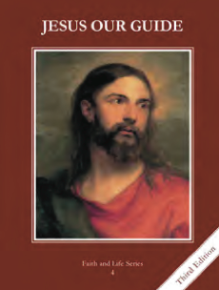
CCD GRADE 4: JESUS OUR GUIDE
Chapter 18: Loving Others
• PREPARATION – How to Get Ready

Teacher’s Manual: pp. 218-223
Materials: powerpoint
• PROCLAMATION – Main Theme

The fourth commandment teachers us to honor those in authority and the fifth commandment teaches us to love and respect others.
• EXPLANATION – Content of Lesson

- The Fourth Commandment tells us to honor our father and mother.
- Review the greatest commandment and how God shows His love for us
- Review the fourth commandment and ways we live and break the commandment
- We honor our father and mother by obeying them, speaking respectfully to them, helping them, and praying for them.
- Discuss ways that parents show their love and ways they can respect their parents
- Besides our parents we should obey teachers, priests, and people our parents have put in charge of us, such as babysitters.
- Brainstorm people in authority
- Discuss the importance of people in authority and why they should be obeyed/respected too
- The Fifth Commandment is You shall not kill.
- Review the fifth commandment and ways to live and break the commandment—keeping in mind that the human person is both body and soul
- Review corporal works of mercy as ways to live the fifth commandment
- Jesus asks us to forgive those who have hurt us.
- Review the spiritual works of mercy, especially forgive all injuries
- Use powerpoint slides to discuss forgiving injuries
• APPLICATION – Connecting it to Students

- Brainstorming ways to show love to their parents; praying to forgive those who have hurt them
- Make an acrostic with each student’s name.
- http://safeshare.tv/w/lxgzPuMWXU TobyMac “Speak Life” to emphasize the impact we have on one another by keeping the Commandments.
• CELEBRATION - Conclusion

- Close with intercessory prayer for people in their families or others that are in need of prayer. Include prayers of forgiveness for those who have hurt them.

