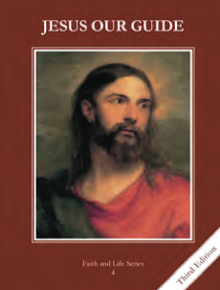
CCD GRADE 4: JESUS OUR GUIDE
Chapter 19: Growing in Love
• PREPARATION – How to Get Ready

Teacher’s Manual: pp. 228-235 for personal preparation
Materials: puzzle
• PROCLAMATION – Main Theme

The sixth through tenth commandments are different ways of showing love to others.
• EXPLANATION – Content of Lesson

- The Sixth and Ninth Commandments protect marriage and families.
- Review the role of families and what marriage is
- The Sixth and Ninth Commandments forbid unfaithfulness in marriage and impure thoughts and desires.
- Review sixth and ninth commandments and ways we live and break the commandments
- Define purity and discuss ways to remain pure. Tell St. Maria Goretti’s story.
- The Seventh Commandment tells us we must never steal.
- Discuss stewardship
- Review the seventh commandment and ways we live and break the commandment
- Review the tenth commandment and ways we live and break the commandment
- Discuss scenarios and parables related to the seventh and tenth commandments
- Listen to VeggieTales “Thankfulness Song”
- The Eight Commandment teaches us to tell the truth.
- Discuss reasons why we lie
- Review the eighth commandment and ways we live and break the commandment
- When we have sinned, we must go to Confession and make reparation for our sins.
- Discuss reparation
- Read page 91 “Joyful Goodness”
• APPLICATION – Connecting it to Students
- Discuss Commandment scenarios and reasons why we break the Commandments.
- Lead the students in an examination of conscience, with specific attention to commandments 6-10
- http://safeshare.tv/w/YcaKezmucT VeggieTales “Thankfulness Song”
• CELEBRATION - Conclusion
- Pray the ESCAPE prayer. E=examine your conscience S=be sorry for your sins C=confess your sins A=receive absolution PE=do your penance
- If it’s not possible to go to confession, just make an examination of conscience

