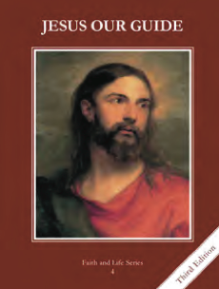
CCD GRADE 4: JESUS OUR GUIDE
Chapter 2: The World’s First Murder
• PREPARATION – How to Get Ready

Teacher’s Manual: pp. 16-23
Materials: small paper sacks, markers/crayons, slips of paper
• PROCLAMATION – Main Theme

The Savior would come from Adam and Eve’s third son, Seth.
• EXPLANATION – Content of Lesson

- Cain and Abel were Adam and Eve’s first sons.
- Abel became a shepherd
- Cain became a farmer
- Abel prefigured Christ and offered his best lamb.
- Both made sacrifices
- discuss what makes something a sacrifice and some examples
- Cain brought an offering to the Lord of his crops
- Abel brought one of the best the firstlings from his flock which pleased the Lord
- Cain was jealous and slew Abel.
- God warned Cain about his jealousy, but he didn’t listen
- Thoughts lead to actions and because Cain was jealous he killed his brother Abel
- Discuss that all actions have consequences and the consequences of Cain’s sin
- God would bring forth a Savior through the lineage of Seth.

• APPLICATION – Connecting it to Students

- What sacrifices can we make? What is the intention of our heart when we are making a sacrifice—love of God or some other reason? What are some of the consequences of our actions—now and also for eternity?
- Make a sacrifice bag
- That Story of Cain and Abel—tells the story of Cain and Abel http://safeshare.tv/w/WqjJMZYtaK
• CELEBRATION - Conclusion

- Pray the Act of Contrition; focusing on the point that we are heartily sorry because we offend God, not just because we are afraid of not going to Heaven.

