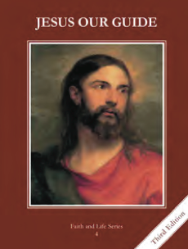
CCD GRADE 4: JESUS OUR GUIDE
Chapter [20]: [Jesus, Our Guide]
• PREPARATION – How to Get Ready

Teacher’s Manual: p. 240-247
Materials: slips of paper, pencils
• PROCLAMATION – Main Theme
Jesus is both God and man. He performed miracles and desires us to be in Heaven with Him.
• EXPLANATION – Content of Lesson

- Jesus is the Son of God, The Second Person of the Blessed Trinity, true God and true man.
- Review the Annunciation and the Trinity
- Brainstorm things that Jesus could do as a man and things He could do as God
- Jesus is one Divine Person with two natures – one divine and one human.
- Ask the children: “who are you/what are you?”
- Define person and nature
- Communicate Jesus is one divine Person with 2 natures
- Watch video on Jesus being both God and man
- Jesus performed miracles so people would believe His teachings and know that He is God.
- Review the difference between miracle, magic and coincidence
- Activity: Miracles Pictionary
- Brainstorm miracles of Jesus that they remember
- Look up difference miracles and classify them
- Jesus is the only way to perfect joy and union with God in heaven.
- Spend a few moments looking at pictures of the Sacred Heart—ask questions about it
- Discuss Jesus as the way to perfect joy and union with God
• APPLICATION – Connecting it to Students

- Challenge them to evaluate their relationship with Jesus; how He is working in their lives.
- Play Pictionary with examples of miracles that the students come up with
- Video https://www.youtube.com/watch?v=0BCNohRTGq8 "How can Jesus be Both God and Man?"
• CELEBRATION - Conclusion

- Pray the Litany of the Holy Name of Jesus

