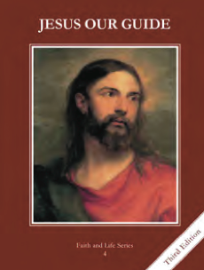
CCD GRADE 4: JESUS OUR GUIDE
Chapter [23]: [Bread from Heaven]
• PREPARATION – How to Get Ready

Teacher’s Manual: pp. 278-283
Materials: Bibles, Scripture Search papers
• PROCLAMATION – Main Theme

Manna prefigures the Eucharist which is Jesus’ body, blood, soul and divinity.
• EXPLANATION – Content of Lesson

- Jesus gave the apostles this Bread at the Last Supper and gives it to us at every Mass.
- Look up Matthew 26:26-29, Mark 14:22-25, Luke 22:17-20
- Connect the words of the Last Supper to the Mass (you can look read the Eucharistic prayer in the missalette)
- Review the basics of the consecration
- Jesus is truly and wholly present in the Eucharist.
- Watch Matt Maher “The End and the Beginning”—discuss what stood out to them and what it means
- Review the basics of transubstantiation
- Practice memorizing “The Holy Eucharist is the Body, Blood, Soul and Divinity of Jesus under the appearance of bread and wine.”
- To receive the Eucharist worthily means to have a soul free from mortal sin, to fast for one hour beforehand, and to know and believe whom we are receiving.
- Use the PowerPoint to review/teach the 5 steps to worthily receive the Eucharist
- If time, have them act out or give examples of how receiving Holy Communion changes our souls and discuss the fruits of the Mass and Holy Communion
- The Israelites received manna in the desert; Jesus multiplied the loaves to feed the multitudes; and Jesus is the Bread that comes down from Heaven.
- Activity: Scripture search with Exodus 16:4-5, 14-35, Mark 8:1-9, John 6:1-13, Matthew 15:32-37
- Discuss the activity, making it clear that Jesus is the bread that came down from Heaven
• APPLICATION – Connecting it to Students

- Review questions about the consecration and transubstantiation
- Scripture Search
- http://safeshare.tv/w/IIeVqIMQVN Matt Maher “The End and the Beginning” lyrics discuss transubstantiation and Jesus being really present in the Eucharist
• CELEBRATION - Conclusion

- Make a visit to Jesus in the Blessed Sacrament and spend a few minutes in quiet prayer thanking Him for the gift of his presence in the Eucharist.

