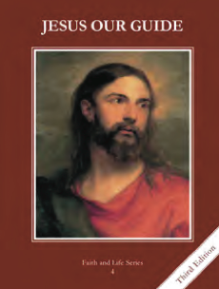
CCD GRADE 4: JESUS OUR GUIDE
Chapter [24]: [Mistakes Along the Way]
• PREPARATION – How to Get Ready

Teacher’s Manual: pp. 290-297
Materials: Commandments scenarios
• PROCLAMATION – Main Theme

Original sin was committed by Adam and Eve, but we still suffer the effects of it. Two types of actual sin that we commit are mortal and venial.
• EXPLANATION – Content of Lesson

- Original sin was the first sin committed by Adam. It consisted of disobedience caused by pride.
- Read/act out/discuss the Fall of Adam and Eve—Genesis 3:1-24
- The effects of Original Sin are still with us, and we must form our conscience to judge correctly what is right and wrong.
- Compare and contrast life before and after the Fall—possibly write the points from the powerpoint on notecards and have them sort them into two groups (before or after the Fall)
- Video of Jiminy Cricket
- Define conscience/discuss how to inform conscience
- Activity: Conscience scenarios
- There are two types of actual sin: mortal and venial.
- Review the difference between actual and original sin
- Use example of venial sin being like a sickness in our soul and mortal sin being like killing our soul.
- Review the requirements for it to be a mortal sin.
- Have them give examples of each.
- We can sin by thought, word, deed, or omission.
- Pray the Confiteor—point out that we sin by thought, word, deed or omission
- Discuss and give examples of each of these

• APPLICATION – Connecting it to Students

- How are we like Adam and Eve? Have them discuss situations where they need a well formed conscience.
- Commandments scenarios
- Jiminy Cricket singing about let your conscience be your guide http://www.safeshare.tv/w/yLNMFurGrp
• CELEBRATION - Conclusion

- Pray the Confiteor or Act of Contrition.

