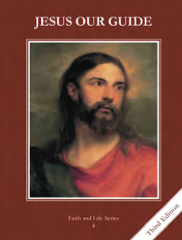
CCD GRADE 4: JESUS OUR GUIDE
Chapter [25]: [Turning Back to God]
• PREPARATION – How to Get Ready

Teacher’s Manual: pp. 304-305, 308-309
Materials: None
• PROCLAMATION – Main Theme

The Sacrament of Confession restores our relationship with God. There are five steps in making a good confession.
• EXPLANATION – Content of Lesson

- Penance and reconciliation are other names for the sacrament of Confession.
- Do you know of something or someone that goes by different names? (Ex. Kleenex, tissue, nicknames for students in the class, etc.)
- Discuss each name of the sacrament and what it emphasizes
- Five steps (Make and examination of conscience, be sorry for sins, intend to avoid sin in the future, confess sins to a priest, do your penance)
- Use the acronym ESCAPE to teach the five steps to a good confession, explain each step
- Penance is a good work that makes up, in part, for what we have done wrong.
- Scenario of breaking a window and needing to pay for the damage
- Discuss penance as our part in making up for what we have done
- A near occasion of sin is a person, place, or thing that puts us in danger of sinning.
- Define/discuss near occasion of sin
- Write scenarios involving near occasions of sin, relevant to grade level (if time, have them act them out)
- When we confess our sins to a priest, it is really Jesus who forgives us.
  - Discuss this point when you teach the five steps to a good confession
• APPLICATION – Connecting it to Students

- Near occasion of sin scenarios
- After the lesson, have them choose a familiar tune and rewrite the lyrics using the main points from the lesson.
- https://safeshare.tv/x/_2kk3jQr2Zc A priest singing about the Sacrament of Confession to the tune of Let it Go
• CELEBRATION - Conclusion

- Make an examination of conscience together

