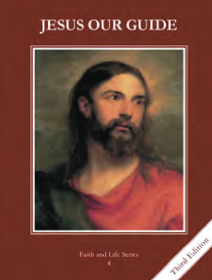
CCD GRADE 4: JESUS OUR GUIDE
Chapter [26]: [The Holy Spirit]
• PREPARATION – How to Get Ready

Teacher’s Manual: pp. 318-322
Materials: paper, crayons/markers, Bibles
• PROCLAMATION – Main Theme

The Holy Spirit is the love between the Father and the Son. He is at work in us and in the world.
• EXPLANATION – Content of Lesson

- The Holy Spirit is the love between the Father and the Son. The love is so real and complete that it is a Divine Person.
- Using the powerpoint discuss who the Holy Spirit is
- The Holy Spirit comes to live in us at our Baptism.
- Use powerpoint to discuss that the Holy Spirit comes to dwell in us at our Baptism and imparts to use the three theological virtues of faith, hope and love.
- The Holy Spirit spoke through, or inspired, the writers of Sacred Scripture.
- Compendium of the Catholic Church #18
- Mary became the Mother of Jesus by the Holy Spirit.
- Read/act out Luke 1:26-38
- Discuss the Holy Spirit’s role in the Annunciation
- At confirmation the Holy Spirit gives an increase of strength to do God’s will and to follow him.
- Read/act out Acts 2:1-41 (could read parts of it as well; discuss key points—they were changed after they received the Holy Spirit
- Discuss Confirmation as our individual Pentecost where we receive the Gifts of the Holy Spirit and are strengthened to do God’s will and follow Him
• APPLICATION – Connecting it to Students

- The Holy Spirits inspires us as well as the Gospel writers, Mary, etc. How do we respond to the Holy Spirit? How does the Holy Spirit change us? Where do you see the Holy Spirit working in your life?
- At the end of the lesson give each person or group a Scripture and have them draw/make an image of the Holy Spirit based on the Scripture.
- http://safeshare.tv/w/ANVBjZciHw How does the Holy Spirit work in our lives; discuss who the Holy Spirit is and how he works in our lives.
• CELEBRATION - Conclusion

- Pray the prayer to the Holy Spirit

