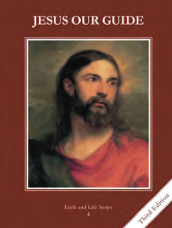
CCD GRADE 4: JESUS OUR GUIDE
Chapter [27]: [The Church of Christ]
• PREPARATION – How to Get Ready

Teacher’s Manual: pp. 328-329, 332-333
Materials: paper, markers, colored pencils, crayons
• PROCLAMATION – Main Theme

Jesus established the Catholic Church, which includes all those on earth, in heaven and in purgatory. The Pope is the leader and is infallible when teaching on faith and morals.
• EXPLANATION – Content of Lesson

- The mystical body of Christ, the Church, includes us on earth, those in purgatory, and those in Heaven.
- Discuss the difference between Church and church
- Teach who belongs to the Church
- God’s people in the Old Covenant were the Israelites. God’s people in the New Covenant are those who belong to His Church.
- Review covenant and the major covenants
- Discuss the old covenant and new covenant (using powerpoint)
- Jesus put Peter and the Apostles, and their successors, the Pope and bishops, in charge of the Church.
- Read Matthew 16:13-20; What happens without a leader? Discuss Peter’s role as leader of the Church
- Define Magisterium; why is the magisterium important?
- The special gift of the Holy Spirit that keeps the Pope’s teaching free from error when he teaches about faith and morals in called infallibility.
- Mt 16:18—discuss that the gates of hell will not prevail against the Church
- Define and discuss infallibility; what are things that would be infallible? What would not?
- We should encourage others who are not Catholic to seek the fullness of truth found in the Catholic Church.
- Watch The Spirit and the Bride by Matt Maher, discuss how Jesus wants all to be a part of the Catholic Church
- Discuss ways that we can encourage others through witness, love, truth, etc. to know Jesus in the Catholic Church
• APPLICATION – Connecting it to Students

- What happens without a leader? (at home, in the classroom, etc) What is the only Church that Jesus founded? Why does He want all to be a part of the Catholic Church?
- Make an advertisement for the Catholic Church. It could be a poster, TV or radio commercial, billboard design, etc.
- http://safeshare.tv/w/LjyxILdDBT The Spirit and the Bride by Matt Maher; main message is that the Holy Spirit and the Church are calling Jesus to come again.
• CELEBRATION - Conclusion

- Pray the Nicene Creed

