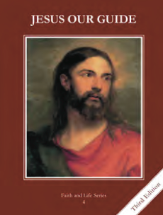
CCD GRADE 4: JESUS OUR GUIDE
Chapter [28]: [Channels of Grace]
• PREPARATION – How to Get Ready

Teacher’s Manual: pp. 341-347
Materials: paper, crayons, markers
• PROCLAMATION – Main Theme

Grace, a share in God’s life, is normally received through the seven sacraments.
• EXPLANATION – Content of Lesson

- Grace is a gift from God; it is a share in God’s own life; and it helps us love Him and our neighbors and to get to Heaven.
- Make observations about Our Lady of Grace picture
- Define grace; why is grace necessary?
- Discuss nine things to know about grace (on powerpoint); give examples
- Explain two different kinds of grace (on powerpoint)
- The normal way we receive grace is through the sacraments.
- Parallel natural life with supernatural life (sacraments)
- Use diagram to explain how the sacraments are channels of grace
- Review the seven sacraments.
- Watch Seven Sacraments by Outside da Box
- Define sacrament as an outward sign instituted by Christ to give grace
- Overview of categories of sacraments—initiation, healing and vocation
- Review the basics (institution, form, matter, minister, who can receive); if time, review the effects of each sacrament
• APPLICATION – Connecting it to Students

- Why is grace necessary? When have you received grace?
- Draw symbols for each of the seven sacraments
- http://safeshare.tv/w/GTFVKqEXjL Seven Sacraments by Outside da Box—gives an overview of the seven sacraments
• CELEBRATION - Conclusion

- Radiating Christ by John Henry Newman (on powerpoint)

