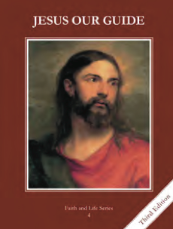
CCD GRADE 4: JESUS OUR GUIDE
Chapter [29]: [Our Mother, Mary]
• PREPARATION – How to Get Ready

Teacher’s Manual: pp. 356-363
Materials: Bible, paper, pencils
• PROCLAMATION – Main Theme

Mary was chosen by God. She is our mother and intercessor.
• EXPLANATION – Content of Lesson

- Mary is the New Eve.
- As an introduction watch the video on Mary.
- Compare Mary and Eve; pointing out that Mary is what Eve was meant to be.
- The Immaculate Conception is the special gift God gave to Mary in keeping her free from sin from the first moment of her life.
- Review that Mary was conceived immaculately, without original sin.
- God’s taking Mary, body and soul to heaven at the end of her life is called the Assumption.
- Review the difference between the Ascension and the Assumption
- Teach the facts about the Assumption, that Mary was assumed body and soul into Heaven.
- Mary is our mother and intercedes with her Son for us so that we will follow Jesus.
- Discuss what it means to be a mother? What are some things you love about your mom?
- Read John 19:25-27
- What does it mean that Mary is our Mother?
- At the wedding at Cana Mary asked Jesus to help when the wine ran out, and Jesus turned water into wine. Mary said. “Do whatever He tells you.”
- Read/act out John 2:1-11;
- Discuss the event
- Point out that Jesus listened to Mary when she brought the need of the couple to Him and that she does the same for us.
- Activity: write a letter to Mary as your Mother. Include some needs that you want her to bring to Jesus.
• APPLICATION – Connecting it to Students

- Make connections between their mom and Mary, our Mother. How could you say yes to God like Mary did?
- Have the students write a letter to Mary, their Mother, including things that they want her to intercede for.
- http://safeshare.tv/w/SpblCpXByD What is the Immaculate Conception? Gives background info on Mary
• CELEBRATION - Conclusion

- Pray the Memorare

