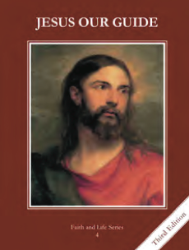
CCD GRADE 4: JESUS OUR GUIDE
Chapter 3: Turning Away from God
• PREPARATION – How to Get Ready

Teacher’s Manual: pp. 28 baptismal promises, read chapter for background
Materials: Powerpoint (at least print the slides)
• PROCLAMATION – Main Theme

After flooding the world, God made a covenant with Noah. Even when Noah’s descendants turned from God, God wanted to lead them back to Himself.
• EXPLANATION – Content of Lesson

- The world was filled with sinful men, so God decided to flood the world. The flood prefigured Baptism and the ark prefigured the Church.
- Use imagination and pictures to elaborate: Noah loving God in the midst of sinful people, Noah building an ark in the desert, size of ark, animals and noise in ark
- Use organizer to show how flood and ark prefigure Baptism and Church
- God made a covenant with Noah.
- Ask students to describe a time they saw a rainbow.
- Read text from last paragraph on p. 21 to 2nd paragraph on p. 22
- Have students act out Noah offering his best animals in sacrifice and God promising to never again send a destroying flood. Include a quick marker rainbow if possible.
- God makes a covenant with us at baptism.
- The descendants of Noah built a great city and grew prideful. When they decided to build a tower to reach the Heavens, God confused their language in order to show them from whom their talents truly came.
- Show Noah’s family tree and world map. Describe a personal story of being unable to understand a person’s language and let students share stories among selves briefly.
- Read page 22 “The Tower of Babel” and act.
• APPLICATION – Connecting it to Students

- What are ways we are like/unlike Noah in our trust of God, no matter what others think? What are times we have not been able to understand others’ languages? Do we always give God the credit when we are able to do something?
- Activity: acting out Noah’s sacrifice/God’s promise and Tower of Babel, sharing stories
- Video: Building the Ark https://youtu.be/VeeNfVI0_TU visual representation
• CELEBRATION - Conclusion

- Renew baptismal promises on page 28 of teacher’s manual. Sing an “Alleluia” song out of your hymnal in celebration of baptism, or just have an “Alleluia” party on the way out of class.

