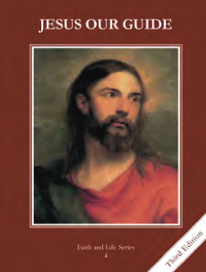
CCD GRADE 4: JESUS OUR GUIDE
Chapter 4: God Prepares a People for the Savior

• PREPARATION – How to Get Ready

Teacher’s Manual: p 41-43
Materials: slides (at least printouts – if no computer, find a picture of stars/sand) optional – grains of sand to count for activity
• PROCLAMATION – Main Theme

God made a covenant with Abraham, who had enough faith in God to sacrifice his only son, Isaac.
• EXPLANATION – Content of Lesson

- God called Abram.
- Consider being asked to blindly follow God’s promises; look at map of Abram’s journey. Read page 24.
- Use slide pictures of Canaan, sand, and stars to explain God’s gift of Canaan and heirs.
- God made a covenant with Abraham.
- Understand covenant; elaborate baptismal covenant.
- Read “The Covenant” on page 25-26. Notice covenant conditions and name changes.
- Abraham, in faith, took Isaac to sacrifice him at God’s command.
- Ask students questions about the nature of tests and how Abraham felt.
- Act out the sacrifice of Isaac as page 26 is read.
- Isaac prefigures Christ, the Son of God.
- Have two students model Isaac and Jesus as their comparison slide is presented.
• APPLICATION – Connecting it to Students

- What would you do if…(slide questions on faith), what are/why do we have tests, how would Abraham have felt
- Act out sacrifice of Isaac; compete to see who can count the most grains of sand in a minute
- Video: http://safeshare.tv/w/CRFUIrUGFA Danielle Rose “Abraham’s offering”—puts the Scripture to song and compares his sacrifice with the sacrifice of Jesus.
• CELEBRATION - Conclusion

- Go outside to look at the stars. After looking up for a silent moment, thank God for his faithfulness and pray a “Glory Be.” If it’s cloudy or sunny, have each student take a moment to consider something with which he/she needs to trust God. Pray aloud asking for trust.

