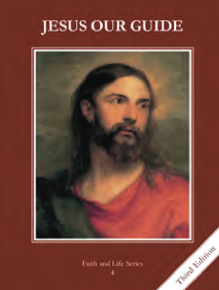
CCD GRADE 4: JESUS OUR GUIDE
Chapter 5: The People of Israel
• PREPARATION – How to Get Ready

Teacher’s Manual: pp. 55-56
Materials: print PowerPoint slides if unable to use on computer during class
• PROCLAMATION – Main Theme

Jacob tricked his family, but Laban tricked Jacob. God brought good out of evil and blessed Jacob with twelve sons who became the People of Israel.
• EXPLANATION – Content of Lesson

- Jacob traded for Esau’s birthright and tricked Isaac for his blessing.
- Develop birthright concept. Dramatize Jacob and Esau’s exchange of stew and birthright while or after reading page 28.
- Dramatize Jacob tricking Isaac for his blessing while or after reading page 28.
- Laban tricked Jacob into marrying Leah.
- Ask students to describe times they were tricked. Focus on how they felt.
- Dramatize Laban tricking Jacob into marrying Leah while or after reading page 30 “Wives for Jacob.”
- Discuss the 8th Commandment.
- God changed Jacob’s name to symbolize the new life he would begin. He had twelve sons who would become the People of Israel.
- Read Genesis 32:23-33. Dramatize it.
• APPLICATION – Connecting it to Students

- What blessings do you want? When have you been tricked and how did you feel? What name changes do you know about? Have you ever wrestled someone like Jacob wrestled the angel?
- Act out Jacob and Esau’s exchange, Jacob’s trickery, and Jacob’s name change.
- http://safeshare.tv/w/QNqmZtBhwb Story of Jacob and Esau
• CELEBRATION - Conclusion

- Within the closing prayer, have each student thank God for a blessing they have received and beg God for a blessing they hope for eternally. This can be done silently or out loud at the teacher’s discretion. After this, pray out loud for the grace to be honest. End with a “Glory Be.”

