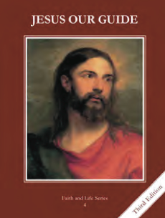
CCD GRADE 4: JESUS OUR GUIDE
Chapter 6: Joseph Goes to Egypt
• PREPARATION – How to Get Ready

Teacher’s Manual: pp. 33-34.
Materials: powerpoint slides, video, paper
• PROCLAMATION – Main Theme

Joseph’s brothers sold him into slavery because they were jealous. God brought good out of evil.
• EXPLANATION – Content of Lesson

- Joseph’s brothers were jealous of him and sold him into slavery.
- Discuss envy and how to deal with it. Act out Joseph’s dreams.
- Act out Joseph’s brothers selling him while or after reading the second column of page 33 into page 34.
- God brought good out of the brothers’ jealousy.
- Explain Pharaoh’s dreams.
- Watch video clip of dreams and/or act them out.
- Discuss how God saved thousands from starvation through Joseph.
- Joseph prefigures Jesus.
- Go through powerpoint t-chart of similarities. Each student could be responsible for remembering, explaining, or pictorially representing each similarity on a white board or piece of paper.
• APPLICATION – Connecting it to Students

- Discuss how to deal with envy. Discuss how God could bring good from troubles in their own lives.
- Act out Joseph’s dreams and Joseph being sold. Pictorially represent each similarity between Joseph and Jesus.
- Watch this video clip and/or act out the dream. (2 parts)
- https://www.youtube.com/watch?v=OpYT-vEteqc
• CELEBRATION - Conclusion

- For a closing prayer, practice gratitude as a help against envy by making either a verbal or written list of all the blessings the class can remember that day.

