†
J.M.J.

Jesus tells us to tell others about Him: Acts 1:1-11

(https://biblecraftsforyourkiddos.wordpress.com/2014/04/27/jesus-tells-us-to-tell-others-about-him-acts-11-11/)
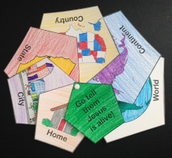
This craft was made to go along with Jesus’ ascension, but it is not a traditional Jesus in the clouds craft. It focuses on what Jesus said in Acts 1:8. Jesus wants us to tell others about Jesus but reaching to the ends of the earth is pretty overwhelming. Start small and work your way out!
Go and Tell
Objective: Like, Mary children will tell others of Jesus with this remind of where we should go.
Supplies:
4 pages for each child (state & city, go tell them & country, home & continent, and the world)
Scissors
Brads
Hole punches
Crayons or markers or colored pencils
Time: 15-20 minutes
Preparation: None.
In Class: Pass out the pages to the children making sure they each have the 4 different pages.
- The children can color each of the pictures and come up with ways they can share about Jesus in each of the venues.
- Then have the children cut out each of the 6 sized pentagons.
- Place them in size order.
You can use the hole punches to punch out the black circles at the top of each picture to make adding the brad easier. Add the brad. Download Go and tell the world

