†
J.M.J.
NAME:
The Giver of Life
Holy Spirit Mobile
- Draw and cut out Holy Spirit symbols. The students may use the following symbols in their mobiles: dove, fire, light, clouds, powerful wind.
- Students may come up with other symbols and incorporate the seven Gifts of the Holy Spirit in their mobiles.
- Punch holes in the symbols.
- Arrange coat hangers as shown below.
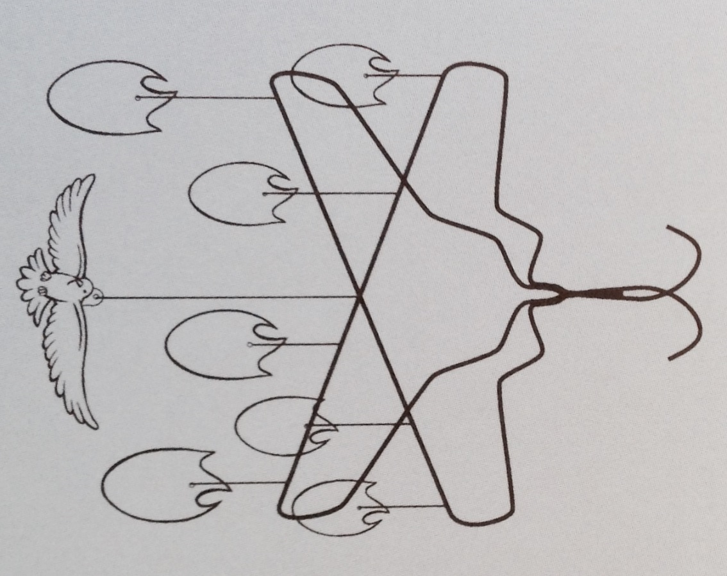
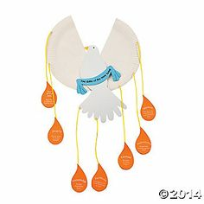
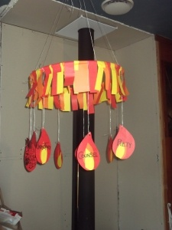
- Attach the symbols to the hangers with yarn.
Variations

Sample

