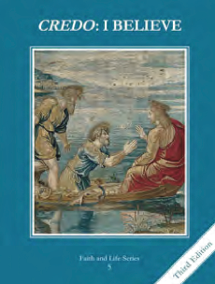
CCD GRADE 5: CREDO: I BELIEVE
Chapter 24: The Mystical Body
• PREPARATION – How to Get Ready

Teacher’s Manual: pp. 234, 236, 238
Materials: CCC #787-795 (Church as Body of Christ), #846-848 (Outside the Church there is no salvation)
• PROCLAMATION – Main Theme

The Church is the Mystical Body of Christ. Jesus is the Head and all those who are baptized are members of the Body. The Communion of Saints includes the Church Triumphant (saints in heaven), Church Suffering (poor souls in purgatory) and Church Militant (baptized souls on earth).
• EXPLANATION – Content of Lesson

- What makes up a body?
- Discuss how all parts of a body are important and work together.
- Read St. Paul’s conversion and how Jesus identifies Christians as part of Himself.
- The Mystical Body of Christ
- Discuss who makes up the various parts of the Mystical Body and their part in it.
- Identify terms for the Communion of Saints.
- Identify Baptism as the condition for membership in the Mystical Body and confession to restore membership after mortal sin.
- Why did Jesus give us a Church?
- The Church “is God’s visible plan of God’s love for humanity.”
- The Church continues Jesus’ saving work on earth and is a sure guide to salvation.
- We love and pray for Christians who are separated from the Church.
- Our membership in the Church is strengthened by the Eucharist.
• APPLICATION – Connecting it to Students

- Complete the Mystical Body of Christ diagram during the lesson discussion.
- Video: https://youtu.be/HJL7Eis0Rb0
• CELEBRATION - Conclusion

- Read aloud I Corinthians 12:13-21 for students to reflect and pray. Have them answer the reflection questions in their journals.

