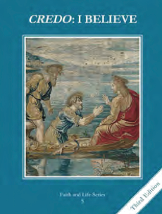
CCD GRADE 5: CREDO: I BELIEVE
Chapter 25: The Identity of the Church
• PREPARATION – How to Get Ready

Teacher’s Manual: pp. 244, 246, 248
• PROCLAMATION – Main Theme

The Catholic Church is the one true church founded by Jesus Christ. The Church can be identified by four marks: one, holy, catholic and apostolic.
• EXPLANATION – Content of Lesson

- Identity is based on recognizable characteristics.
- Discuss four objects that start with similar qualities, but are identified by differences.
- Identify the Catholic Church by its four marks as one, holy, catholic and apostolic.
- Discuss the four marks of the Church.
- One: in belief, worship and leadership
- Holy: in her Founder (Jesus), members and saints
- Catholic: universal, for all people in all times and in all places
- Apostolic: her ministers receive their powers from the Apostles by an uninterrupted chain of succession
- References for the four marks in Scripture.
- Symbols of the Church (from Scripture)
- Mystical Body of Christ
- Sheepfold
- Vineyard
- Bride
- Ark/Ship
• APPLICATION – Connecting it to Students

- The handout called “How Old is Your Church?” is a very insightful look at where different Protestant denominations began and would be a good resource to give the students.
- For the Scripture slide you can have students look up the passages in groups and guess which mark, or you can read the passage and have them identify the mark.
- For the symbols of the Church, you can have students draw a picture to illustrate one of the symbols and share it with the group.
• CELEBRATION - Conclusion

- Watch the video of a bishop recapping each of the four marks to review.
- Guide students to pray with Matthew 16:16-18 and have students journal about their experience.

