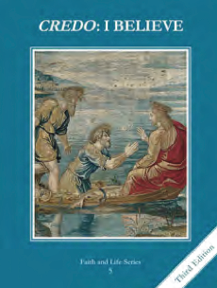
CCD GRADE 5: CREDO: I BELIEVE
Chapter 26: The Church Rules
• PREPARATION – How to Get Ready

Teacher’s Manual: pp. 254, 256, 259 (chalk talk)
• PROCLAMATION – Main Theme

The Church is divine and human. Through apostolic succession, the pope, bishops, priests and deacons have roles of service in their leadership of the Church. The precepts of the Church bind all Catholics as a minimum requirement of membership.
• EXPLANATION – Content of Lesson

- The Church as divine and human.
- Church is divine because Jesus as Founder is divine and Holy Spirit guides
- Church is human because Jesus as Founder became human and members are human
- Apostolic succession
- Apostles were given power to govern/serve the Church by Jesus
- Apostles receive and pass on this power through the Holy Spirit
- Church Hierarchy is the governing order of the Church and includes: Pope, bishops, priests and deacons.
- Precepts of the Church
- Key vocabulary to understand the precepts
- These Church rules are the bare minimum to show our commitment to a friendship with Jesus.
• APPLICATION – Connecting it to Students

- Complete the Church Hierarchy chart as you discuss those slides.
- You might want to make color-coded bracelets with pony beads as a way to remember the precepts.
- Watch/listen to the music video to a Catholic rapper on the hierarchy of the Church. The last minute or so could be cut as it is just an acknowledgement of the singer’s connections to various priests, etc.
• CELEBRATION - Conclusion

- Lead students in Lectio divina on John 21:15-17, 19b. Have students journal afterward about their prayer.

