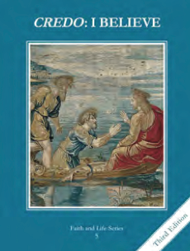
CCD GRADE 5: CREDO: I BELIEVE
Chapter 27: Teach All Nations
• PREPARATION – How to Get Ready

Teacher’s Manual: pp. 264-269
Materials: Bibles
• PROCLAMATION – Main Theme

Sacred Scripture and Sacred Tradition are gifts from Jesus to the Church. The magisterium safeguards these gifts by the power of the Holy Spirit. The Bible has many uses and is especially a powerful means of prayer.
• EXPLANATION – Content of Lesson

- Where did the Bible come from?
- The apostles and their successors had the authority to determine which holy writings would be part of the Bible.
- The teaching authority of Peter and the apostles is passed down to the Pope and the bishops in union with him. This is called the Magisterium, or the teaching Church.
- The Council of Hippo in 393 was a major ecumenical council that determined the canon of Sacred Scripture.
- The Bible is God’s Word, but Jesus is God’s ultimate Word.
- God’s revelation: He revealed Himself to man in multiple ways so we could know Him
- Sacred Scripture – written revelation
- Sacred Tradition – oral revelation
- Magisterium – teaching authority of the Church that safeguards revelation
- Arrangement of the Bible
- Uses of the Bible
- Books of the Bible
• APPLICATION – Connecting it to Students

- Use the packet for students to complete as you work through the lesson.
- Students will have the opportunity to learn how to do “sword drills” to look up passages of the Bible.
- Video: https://youtu.be/VaZuJfPBLKo
• CELEBRATION - Conclusion

- The lectio divina part at the end is critical to helping students not just to “know” about the Bible, but to experience Jesus speaking to their hearts through His revealed Word. Have them journal about their experience at the end.

