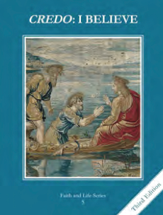
CCD GRADE 5: CREDO: I BELIEVE
Chapter 23: The Giver of Life
• PREPARATION – How to Get Ready

Teacher’s Manual: pp. 277-288
• PROCLAMATION – Main Theme

God, the Holy Spirit is the love between the Father and the Son. The Holy Spirit comes to us in many ways.
• EXPLANATION – Content of Lesson

- The Holy Spirit descended upon Mary and the apostles in the upper room. L2
- Immediately after the Holy Spirit descended, the Apostles could speak in many languages, Peter proclaimed the gospel, and over three thousand people were baptized. L2
- The Holy Spirit is the love between the Father and the Son. L3
- The Holy Spirit protects the Pope and all the bishops in union with the Pope from teaching error in matters of faith and morals. L4
- The Holy Spirit fills our souls at Baptism and pours out His gifts at Confirmation. L4
• APPLICATION – Connecting it to Students

- Class Discussion: How can we allow the Holy Spirit to act in our lives? How does the Holy Spirit prompt us to become holier? How can we say yes to the Holy Spirit and grow in holiness?
- Activity: Holy Spirit/Gifts of the Holy Spirit mobile
- Video: https://safeshare.tv/x/ss5d519711d7403
  - This is the Pentecost scene from the series The Bible.
• CELEBRATION - Conclusion

- Pray together that the Holy Spirit and His gifts may be active in our lives.
- Sing Come, Holy Ghost or another Pentecost/Holy Spirit hymn.

