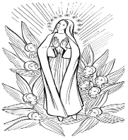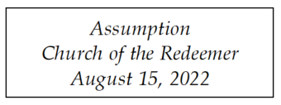
GATHERING SONG: “Immaculate Mary”
1. Immaculate Mary, your praises we sing; you reign now in splendor with Jesus, our King. Ave, ave, ave Maria! Ave, ave Maria!

2. In glory for ever now close to your Son, all ages will praise you for all God has done. Ave, ave, ave Maria! Ave, ave Maria!
Traditional Lourdes melody.

COLLECT
GLORIA
Glory to God in the highest, and on earth peace to people of good will.

1. We praise you, we bless you, we adore you, we glorify you, we give you thanks for your great glory, Lord God, heavenly King, O God, almighty Father.

2. Lord, Jesus Christ, Only Begotten Son, Lord God, Lamb of God, Son of the Father, you take away the sins of the world, have mercy on us; you take away the sins of the world, receive our prayer; you are seated at the right hand of the Father, have mercy on us.

3. For you alone are the Holy One, you alone are the Lord, you alone are the Most High, Jesus Christ, with the Holy Spirit, in the glory of God the Father. Amen.
Excerpts from the English translation of The Roman Missal, copyright 2010, International Commission on English in the Liturgy Corporation. Music: Mass of Renewal, by William Gokelman & David Kauffman. Copyright 2010 GFTSMusic Publishing Company, Inc. Administered by International Liturgy Publications. All rights reserved.

FIRST READING: Revelation 11:19a; 12:1-6a, 10ab

PSALM 45: “The Queen Stands”
Please repeat refrain after cantor the first time and sing after the verses:

The Queen stands at your right hand, arrayed in gold.
By Kevin Keil. Refrain text copyright 1969, 1981, ICEL All rights reserved. Used with permission. Verses text copyright 1970, CCD. All rights reserved. Used with permission. Music copyright 1993, Cooperative Ministries, Inc. All rights reerved. Reproduced with permission under License #A-701559. OneLicense.net.

SECOND READING: 1 Corinthians 15:20-27
GOSPEL ACCLAMATION: “Alleluia! Give the Glory”
Alleluia! Alleluia! Allelu-ia! Give the glory and the honor to the Lord! (Repeat)
Copyright 1991 by Ken Canedo and Bob Hurd. Published by OCP Publications. All rights reserved. Used with permission

GOSPEL: Luke 1:39-56

HOMILY

CREED
I believe in one God, the Father Almighty, maker of heaven and earth, of all things visible and invisible.
I believe in one Lord, Jesus Christ, the only Begotten Son of God, born of the Father before all ages. God from God, Light from Light, true God from true God, begotten, not made, consubstantial with the Father; through him all things were made. For us men and for our salvation he came down from heaven: (bow) And by the Holy Spirit was incarnate of the Virgin Mary, and became man. For our sake he was crucified under Pontius Pilate; he suffered death and was buried, and rose again on the third day in accordance with the Scriptures. He ascended into heaven and is seated at the right hand of the Father. He will come again in glory to judge the living and the dead and his kingdom will have no end.

I believe in the Holy Spirit, the Lord, the giver of life, who proceeds from the Father and the Son, who with the Father and the Son is adored and glorified, who has spoken through the prophets. I believe in one holy catholic and apostolic Church. I confess one Baptism for the forgiveness of sins and I look forward to the resurrection of the dead and the life of the world to come. Amen

LITURGY OF THE EUCHARIST: “Hail Mary, Gentle Woman”
Hail Mary, full of grace, the Lord is with you. Blessed are you among women, and blest is the fruit of your womb, Jesus. Holy Mary, Mother of God, pray for us sinners now and at the hour of death. A-men.

Refrain: Gentle woman, quiet light, morning star, so strong and bright, gentle Mother, peaceful dove, teach us wisdom, teach us love.

- You were chosen by the Father, you were chosen for the Son. You were chosen from all women and for woman, shining one.

- Blessed are you among women, blest in turn all women too. Blessed they with peaceful spirits. Blessed they with gentle hearts.
Hail Mary based on Luke 1:28, music and additional words by Carey Landry. Copyright 1975 by Carey Landry and New Dawn Music. All rights reserved. Used with permission.
Preface Dialogue
Priest: The Lord be with you. People: And with your spirit.
Priest: Lift up your hearts. People: We lift them up to the Lord.
Priest: Let us give thanks to the Lord our God. People: It is right and just.

Holy, Holy
Holy, Holy, Holy Lord God of hosts. Heaven and earth are full, full of your glo-ry. Hosanna, Hosanna in the highest. Blessed is he who comes in the name of the Lord. Hosan-na, Hosanna in the highest. Hosan-na, Hosanna in the highest.

Memorial Acclamation
Save us, Savior of the world, for by your Cross and Resurrection, you have set us free.

Amen
A - men, A - men, A - men, A - men, Amen!

The Lord’s Prayer

Sign of Peace
Priest: Lord Jesus Christ, who said to your Apostles: Peace I leave you, my peace I give you, look not on our sins, but on the faith of your Church, and graciously grant her peace and unity in accordance with your will. Who live and reign for ever and ever.
People: Amen.
Priest: The peace of the Lord be with you always.
People: And with your spirit.
Priest/Deacon: Let us offer each other the sign of peace.

Lamb of God
Cantor: Lamb of God, All: you take away the sins of the world, have mercy on us.
Cantor: Lamb of God, All: you take away the sins of the world, have mercy on us.
Cantor: Lamb of God, All: you take away the sins of the world, grant us, grant us peace.
Excerpts from the English translation of The Roman Missal, copyright 2010, International Commission on English in the Liturgy Corporation. Music: Mass of Renewal, by William Gokelman & David Kauffman. Copyright 2010 GFTSMusic Publishing Company, Inc. Administered by International Liturgy Publications. All rights reserved.

Priest: Behold the Lamb of God, behold him who takes away the sins of the world. Blessed are those called to the supper of the Lamb.
People: Lord, I am not worthy that you should enter under my roof, but only say the word and my soul shall be healed.

COMMUNION: “Holy Is God’s Name”
1. My soul proclaims the greatness of the Lord, and my spirit exalts in God my Savior. For he has looked with mercy on my lowliness and my name will be forever exalted. For the mighty God has done great things for me and his mercy will reach from age to age. And Ho-ly, Ho-ly, Ho-ly is His Name.

2. He has mercy in ev’ry generation. He has revealed His power and His glory. He has cast down the mighty in their arrogance, and has lifted up the meek and the lowly. He has come to help His servant Israel. He remembers His promise to our fathers. And Ho-ly, Ho-ly, Ho-ly is His Name.
By John Michael Talbot. Copyright 1980, 1995, 1997 Birdwing Music/BMG Songs, Inc. Print rights administered by EMI Christian Music Publishing. All rights reserved. Used by permission. Published by OCP Publications. Reproduced with permission under License #A-701559. OneLicense.net.

COMMUNION: “Be With Us, Mary”
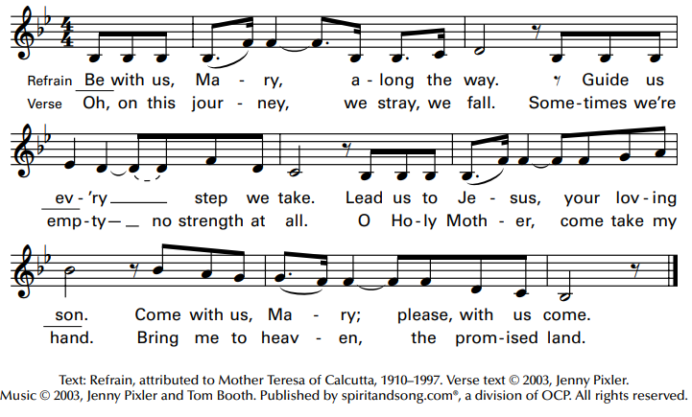

SENDING FORTH: “Hail, Holy Queen Enthroned Above”
1. Hail, holy Queen enthroned above, O Maria. Hail, Queen of mercy and of love, O Maria. Triumph, all ye Cherubim; Sing with us, ye Seraphim. Heav’n and earth resound the hymn: Salve, Salve, Salve Regina.

2. O gentle, loving, holy one, O Maria. The God of light became your Son, O Maria. Triumph, all ye Cherubim; Sing with us, ye Seraphim. Heav’n and earth resound the hymn: Salve, Salve, Salve Regina.
Text adapt. by M. Owen Lee Copyright Willis Music Co. All rights reserved. OneLicense.net License #A-701559

