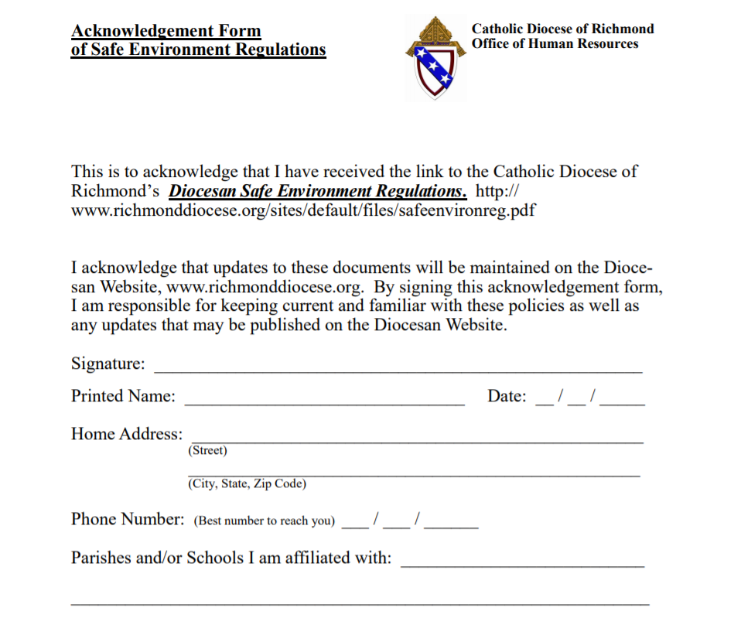

<https://richmonddiocese.org/wp-content/uploads/2018/09/safeenvirjuly2016-final-2018-1.pdf>