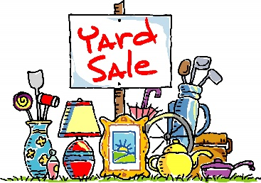
Redeemer’s Haiti Yard Sale is back!

Friday, Sept 16th 2PM-6PM
Saturday Sept 17th 7AM-12PM

Set Aside Items to Donate:
- Please consider donating clean, useful, salable items you no longer want.
- Furniture, rugs, kitchenware, small appliances, decorations
- Silk flowers, picture frames, garden decorations, outdoor furniture, tools
- Toys, games, sporting equipment, bicycles, crafts, musical instruments, books
- Linens, luggage, religious goods, medical equipment, jewelry, electronics
- Children’s clothing - clean, free of stains, in good repair. (No adult clothing please)
Items we cannot accept:
- Baby cribs, car seats, rubber bath toys, plastic books, baby equipment with suction cups Baby walkers with a base less than 36”
- TV's other than flat screen Desktop
- Computer equipment & monitors
- Bed Frames & Mattresses
- Clothing that is faded, stained, or worn out
- Adult Clothing
- Items that are broken
Please save paper grocery bags with handles - Leave them in the Commons in the box marked “Team Haiti Yard Sale”

Donation Drop Off: Monday Sept 12th 12PM-8PM
Tuesday – Wednesday, Sept 13-14 between 8AM – 7:30PM

- Pickup of larger salable items, such as furniture will be available. (Must be on the first floor with easy access) Call the church office at 804-746-4911 to request a pickup no later than Thursday Sept 8th. Pickups will be scheduled for Monday Sept 12th & Tuesday Sept 13th.
- Volunteer:
  - Please consider donating your time. Many Hands make light work!
  - Morning & evening shifts are available Monday Sept 12th- Friday Sept 16th and Saturday Sept 17th from 6:30AM-3PM
  - We need help with set-up, pick-up, sorting, displaying, pricing, baking for the bake sale, greeting customers, cashier sales, and break down/clean up.
  - Sign up on-line with the Sign-Up Genius https://www.signupgenius.com/go/10C0448ADAA23A75-2022 or on paper with the August Commitment Form.
Thank you for supporting our Haiti Ministry. Redeemer is twinned with the Women of AFAL, Lascahobas, Haiti. AFAL is a women’s empowerment group that works to improve the lives of their community by providing education and improving housing. Your help also gives the Mechanicsville community an affordable shopping opportunity! May your many treasures you no longer need, bless someone else’s home!
