**CCM Calendar 2018-2019**

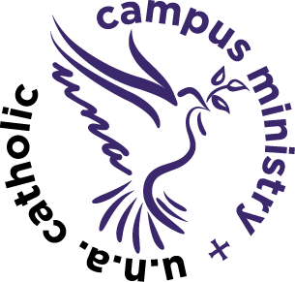

August 26th-1st CCM Mass

September 9th, 16th, 23rd, 30th

October 7th, 14th, 28th (21st fall break)

November 4th, 11th (18th and 25th Thanksgiving break)

December 2nd (December 9th Mass at 11am Our Lady of Guadalupe)

January 13th, 27th (20th- MLK day-no 5:00 pm Mass)

February 3rd, 10th, 24th (17th Winter break-no 5:00 pm Mass)

March 3rd, 10th, 17th (24th- 31st spring break)

April 7th -Last CCM Mass and Meal of the semester (No CCM April 14th due to Palm Sunday or April 21st due to Easter; No CCM April 29th due to 1st Communion)