**CCM Calendar 2019-2020**

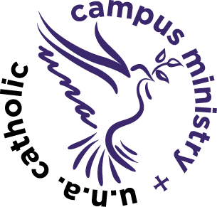

August 25th-1st CCM Mass

September 8th, 15th, 22nd, 29th

October 6th, 20th, 27th (Oct. 13th fall break)

November 3rd, 10th, 17th (Nov. 24th Thanksgiving break)

December (Dec. 1st Thanksgiving break.) (Dec. 8th Mass at 11am Our Lady of Guadalupe)

January 12th, 26th (Jan. 5th- Christmas break)

(Jan. 19th- MLK day-no 5:00 pm Mass)

February 2nd, 9th, 16th (Feb. 23rd Winter break-no 5:00 pm Mass)

March 1st, 8th, 15th (March 22nd- 29th spring break)

April 19th -Last CCM Mass and Meal of the semester (No CCM April 5th due to Palm Sunday or April 12th due to Easter; No CCM April 26th due to 1st Communion)