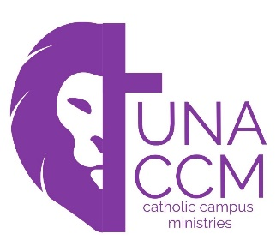**CCM Calendar 2020-2021**

Visit our website at: **unaccm.org**

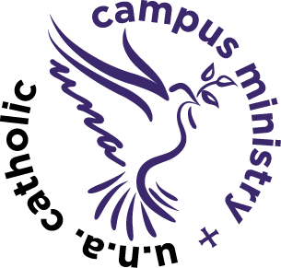**Mass and Meal Schedule:**

August 16th-New student and parent welcome meal following 11:00 am Mass.

August 23rd-Hot dog roast/fire pit-Welcome back dinner!

August 30th

September 13th, 20th, 27th (Sept. 6th-labor day)

***Wednesday, Sept. 2nd, 12:00 pm-2:00 pm Cookies with the Catholics at GUC Atrium***

October 11th, 18th, 25th (Oct 4th fall break)

November 1st, 8th, 15th (Nov. 24th & 29th Thanksgiving break)

*After Thanksgiving, UNA changes to online learning. If you are still in town, December 12th-Our Lady of Guadalupe Mass at 11:00 am followed by a Mexican Meal (if possible)*

January 10th, 24th,31st (Jan. 3rd- Christmas break) (Jan. 17th- MLK day-no 5:00 pm Mass)

February 7th, 14th, 28th (Feb. 21st Winter break-no 5:00 pm Mass)

March 7th, 14th (March 21st- 28th spring break)

April 11th,18th -Last CCM Mass and Meal of the semester (No CCM April 4th due to Easter; No CCM April 25th due to 1st Communion)

*We still plan to serve meals following Mass unless the State deems it unsafe. We will follow CDC guidelines. Masks must be worn at Mass and while going through the food line. We will maintain social distancing while eating. Temperatures will be checked prior to Mass or Meal. Food will be served by a designated “server.”*