‘In-Person’ Advent By Candlelight
St. Owen Parish

Our 19th annual Advent By Candlelight will take place on Thursday, Dec 1, 2022 from 6:30-8:30 pm. Our speaker presentation will begin in St Owen Church, together with musical selections by our music ministry coordinator, Rob Abbott, and cantor Gracie Zingalie, will be live-streamed (and archived for later viewing from our church website). The women of our parish and guests will then enjoy a festive social gathering in the parish center to support our “Sharing with a Family” program and prepare our hearts for Christmas.

We are so pleased to have our Adult Spirituality Director, Michelle Pittel, as guest speaker, with her topic, “Even a manger will provide shelter for those who seek it.” Michelle has a Bachelor of Religious Education, a Master’s in Theology, taught Theology at the high school level, is a Master Catechist, and she worked for the Archdiocese of Detroit as a facilitator. Michelle shares, “To know Jesus, you must be willing to know people and to meet them where they truly are.”

You may reserve your place by simply emailing us the information below and mailing your check to secure your spot. When we receive your check, we will mail/email you a letter explaining the details for the evening. For safety concerns, space in the center is limited this year, so get your reservation in early!

Register now! Email the following information to Cecilia Yee at yee4all@comcast.net
Or call her at 248-855-5471
- Name
- Address
- Home/Cell Phone
- Email Address
- State that you will host a table of 6 for $50.00
- Or… that you will join a Mixer Table for $10.00
- Indicate whether you would like us to
- mail or email your detailed letter
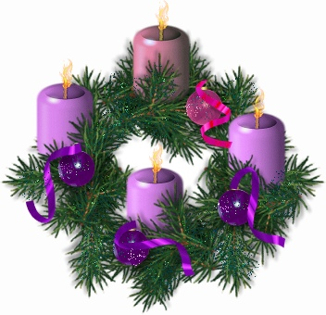
Make checks payable to: St. Owen Church
Add on memo line: Advent By Candlelight

Mail to: Cecilia Yee
4334 Chimney Point
Bloomfield Hills, MI 48302
To join our Advent By Candlelight committee or have questions answered, contact:
Barb Johns - 248-855-9151 barbverdugo@gmail.com
Cecilia Yee – 248-855-5471 yee4all@comcast.net

