

***Come away from the world’s burdens and brokenness, and find your way in Christ at the***

***“Come And See” retreat!***

This overnight retreat at Camp Calvin Crest will feature times for prayer, talks about growing in faith and freedom, small group times, awesome games and outdoor activities, campfires, music, and many surprises along the way!

The retreat will take place at Camp Calvin Crest on Friday, April 12th thru Sunday, April 14th. Parents will be asked to drop off youth by 7:00 pm on Friday at Camp Calvin Crest located at 2870 Co. Rd. 13 and pick up after 10:00 am Mass at St. Patrick on Sunday, April 14th. Students will be asked to bring bedding and pillows. (Families will be asked to donate snack and breakfast items. Sign-up will be shared later.)

If you would like to opt out of spending the night and/or particular meals, the registration fee will be adjusted accordingly. Please contact Lori Kisby with adjusted cost of the retreat.

Registration and a fee of $75 is due by April 2nd. Payment is non-refundable after April 2nd. If the youth cannot make it after April 2nd, you may find someone to take the youth’s spot.

For questions, contact Lori Kisby at [lkisby@stpatsfremont.org](mailto:lkisby@stpatsfremont.org) or Fr. Bill Cremers at [bcremers@stpatsfremont.org](mailto:bcremers@stpatsfremont.org), or the parish office at 402-721-6611. Registration forms are in the parish office, school office or are available online at stpatsfremont.org.

***“Come, he replied, and you will see.” John 1:39a***



**YOUTH REGISTRATION**

Teen Name (first and last)____________________________________________ M_____F_____

Address____________________________________________ City/State __________________

Home Phone__________________________________ Teen Cell Phone ___________________

Birthdate ____________________ Teen’s email ______________________________________

Mother’s Name __________________________________ Mother’s Cell __________________

Father’s Name ___________________________________ Father’s Cell ___________________

Parent’s email address ___________________________________________________________

Parish ___________________________________________ City of Parish __________________

T-shirt size (adult sizes) Small Medium Large XL 2XL 3XL

Grade ______________________

I would like to apply for financial aid. Yes________ No _______ (If applying for financial aid, payment is not required at this time.)

I will be opting out of _____ Spending the night

_____ I will be opting out of the following meals___________________

Registration Fee of $75 is included with the registration. Fee is non-refundable after April 2ndexcept in cases of emergencies.

**Return registration and fee to the following address by April 2nd. Checks should be made payable to St. Patrick Church.**

St. Patrick Parish Office

Lori Kisby, Director Youth Ministries

422 E. 4th St.

Fremont, NE 68025

Any questions contact Lori Kisby at [lkisby@stpatsfremont.org](mailto:lkisby@stpatsfremont.org) or Father Bill Cremers at [bcremers@stpatsfremont.org](mailto:bcremers@stpatsfremont.org) or the parish office at 402-721-6611.

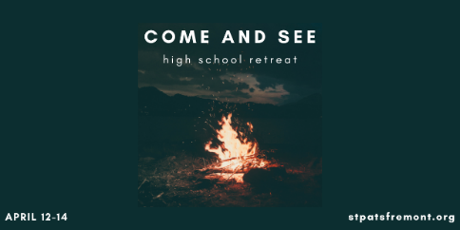

***Medical Information***

Participant’s Legal Name___________________________________________ Birthdate______________________

Doctor’s Name___________________________________________________ Phone ________________________

Parent/Guardian Name(s) ________________________________________________________________________

Mom’s Cell ________________________________________ Dad’s Cell __________________________________

Work Number: (M)__________________________________ (D)________________________________________

Health Insurance__________________________________________ Policy #_______________________________

**Other or Secondary Emergency Contact**

Name _____________________________________________ Relationship________________________________

Home Phone _______________________________________ Cell Phone _________________________________

**Medications:** The above participant will bring all necessary medications which will be well-labeled. Please list all medications, their purpose and frequency of dosage.

Tetanus/Diphtheria Shot (date or year)______________________________________________________________

Dietary Restrictions and Food Allergies: _____________________________________________________________

_____________________________________________________________________________________________

Physical Limitations: ____________________________________________________________________________

Other Special Conditions: ________________________________________________________________________

Recently exposed to contagious disease such as mumps, measles etc. If so, please list the date and disease/condition.______________________________________________________________________________

I hereby warrant that to the best of my knowledge, the above participant is in good health, and I assume responsibility for their health.

Signature_______________________________________________________ Date _________________________

Printed Name _________________________________________ Relationship to Participant __________________

Authorization: I hereby grant permission for non-prescription medications (such as ibuprofen, acetaminophen, throat lozenges, cough syrup, etc.) to be given to my child if necessary. Y___ N____

Signature________________________________________________________ Date _________________________

St. Patrick Church of Fremont and its affiliates will take reasonable care to see that the information on this medical form will be held in confidence.

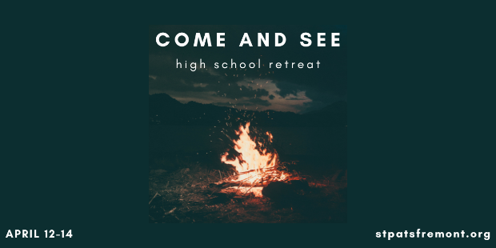

**Parent /Guardian Consent Form and Liability Waiver**

**Camp Calvin Crest, Fremont, NE: April 12-14, 2024**

Participant’s Name _________________________________________________

I grant permission for my youth to participate in this Archdiocesan youth ministry event. This activity will take place under the guidance and direction of Archdiocesan parish/campus youth ministers and/or volunteers from the parishes and schools. A brief description of the event follows:

**Name of Event**: “Come And See” High School Retreat

**Conference Location**: Camp Calvin Crest, 2870 Co Rd. 13, Fremont, Nebraska

**Dates of Event**: April 12-14, 2024

**Transportation**: Each participant will provide their own transportation to camp. When participants go to Mass on Sunday, we will be asking for adult volunteers to transport the youth from camp to St. Patrick.

**Items to Bring**: Pillow, bedding and water bottle.

As parent or guardian, I remain legally responsible for any personal actions taken by the above named minor (Participant). I agree on behalf of myself and my child, to hold harmless and indemnify the parish/school, the Archdiocese of Omaha, and any of their agents, representatives, chaperones or volunteers, for any claims arising from or in connection with any injury or illness the registered participant sustains in connection with its event.

**Photo Release:** Pictures of my child taken during the event may be used in print or electronic media for the purposes of publicity, unless I email [lkisby@stpatsfremont.org](mailto:lkisby@stpatsfremont.org) and indicate I do not consent.

Parent Signature______________________________________ Date _____________________

Printed Name __________________________________________________________________

**Archdiocese of Omaha Youth Code of Conduct**

We are pleased and excited that you are joining us at “**Come And See**”. This Code of Conduct has been developed as a way to help participants understand what is expected of them during the event and contributing toward making the learning healthy and enjoyable for everyone. Please read through the Code of Conduct carefully, as you will be expected honor and uphold it throughout the retreat.

* In order to limit distractions and maintain a prayerful attitude during the retreat, participants will agree to give up their phones and other electronic devices during the retreat. Parents will be given numbers to contact should they need to contact their child. Youth will be given the opportunity to contact parents should the need arise. Youth are asked not to bring their phones at all. If they do bring their phones or electronic devices, they will be kept with a chaperone for safe-keeping.
* If the youth has another activity to attend over the weekend, it is the duty of the parent to contact the sponsors to make them aware of the activity as well as time the youth will leave and return. It is also the parent’s responsibility to provide transportation to the activity.
* Damage: The participants and/or families participants assume responsibility for any damage done to the conference facilities.
* No Guests: While participating in “Come and See”, participants will not invite friends who are not part of the program to come and visit you.
* Participation: Participants are expected to attend all sessions and community activities.
* Dress: Dress throughout the retreat casual but appropriate for a Christian environment: shirts and shoes are required at all times. T-shirts/sweatshirts with alcohol, tobacco, or sexual overtones are not acceptable, nor is immodest clothing exposing any part of under garments, bellybuttons, etc.
* Acceptable behavior: Christian behavior is expected at all times. Respect for individuals, the community, and the various facilities are required. Teasing, harassment (this includes bullying) sexual jokes, inappropriate displays of affection, etc. are considered inappropriate for this Christian environment.
* Tobacco and Drugs: The Archdiocese of Omaha adheres to the State Statues in regards to tobacco products, therefore tobacco products are not allowed by anyone under the age of 18. The purchase, possession or consumption of alcohol or drugs by participants will result in immediate dismissal from the retreat.
* Major infractions of the Code of Behavior and other inappropriate behavior will meet with the same consequences.

*Youth Participant:* I understand and agree to the Code of Conduct, I also understand that my parent(s) or guardian will be notified at the time of any infractions requiring my dismissal from the program, and that I will be sent home at my own expense.

Signature: ____________________________________________________ Date: __________________

*Parent or Guardian:* I agree that my youth shall abide by the rules and regulations outlined in this Code of Conduct. I have reviews it and discussed the Code with my youth prior to signing this form. I agree that if my youth fails to consistently abide by the code or engages in a serious infraction of the Code, he or she may be immediately dismissed and sent home at my expense.

Parent Signature: _______________________________________________ Date: _________________