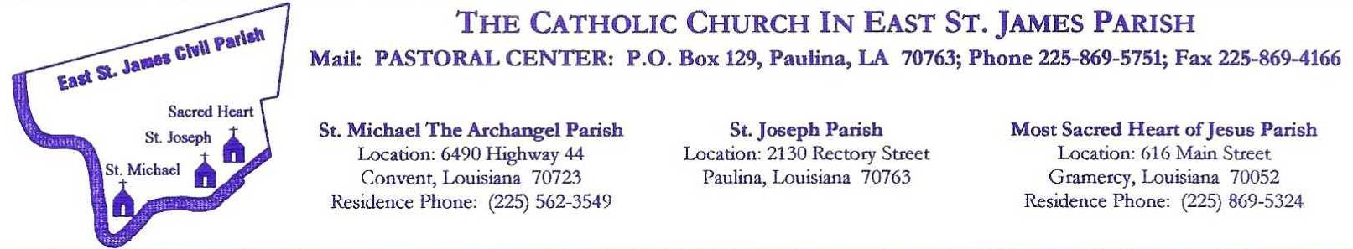
GODPARENT/SPONSOR FORM
I, ______________________________________, am a registered member of
_______________________________________________________(Your Church Parish).
I have been asked to ____ stand as a Godparent; or ____ be a sponsor for Confirmation;
For:____________________________________________________________________.
In accepting this responsibility, I affirm that (please initial each that applies):
___ 1. I have received the three Sacraments of Initiation (Baptism, Eucharist & Confirmation).
___ 2. I am at least 16 years of age.
___ 3. I participate regularly in weekly Mass and give witness to my faith in Christ Jesus by receiving Him in Holy Communion.
___ 4. I believe all that the Catholic Church professes and teaches and I truly make an effort to incorporate these teachings into my daily life.
___ 5. I am aware that I am assuming responsibility to be a good role model for the person I am sponsoring by my life of prayer and by my Catholic example.
___ 6. . I am single, living a Christian life in accordance with the laws of the Catholic Church. I am not cohabitating.
___ 7. If married: I am validly married according to the laws of the Catholic Church. I was married by a priest or deacon; married by a minister with proper dispensation; or had my marriage validated by the Catholic Church
___ 8. I am not the mother or father of the one to be baptized.
Signature of Godparent/Sponsor________________________________________________
Pastor’s Acknowledgement:
___ As Pastor, I verify that the above named person is a registered member of my parish, and fulfilled all the obligations to be a Godparent/Sponsor according to the laws of the Catholic Church.
___ As Pastor, I am unable to verify that the above named person is an active Catholic in my parish.

Pastor Signature: _________________________________________________________________________________

Name of Church Parish: ______________________________________________________________

Date: ________________________ (Parish Seal)

