O most holy heart of Jesus, fountain of every blessing, I adore you, I love you, and with lively sorrow for my sins I offer you this poor heart of mine. Make me humble, patient, pure and wholly obedient to your will. Grant, Good Jesus that I may live in you and for you. Protect me in the midst of danger. Comfort me in my afflictions. Give me health of body, assistance in my temporal needs, your blessing on all that I do, and the grace of a holy death. Amen.
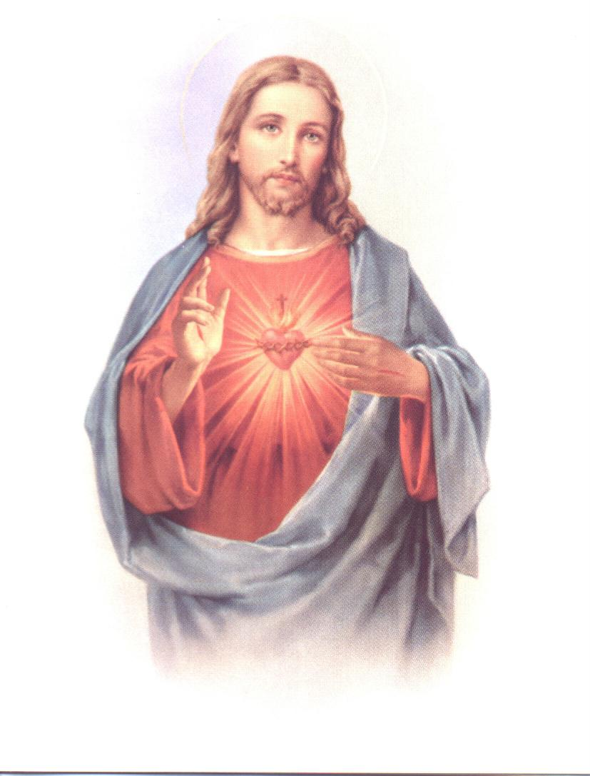
Most Sacred Heart of Jesus
Faith Formation Sessions
2019-20

ALL CLASSES HELD ON MONDAY

MANDATORY PARENT MEETING: Monday, August 5th @ 6:30 P.M. (SH Church)

Grades 1st – 6th 4:15 – 5:30 P.M. Grades 7th – 8th 6:00 – 7:15 P.M.

Dates for Classes:

August 12th 19th 26th

September 9^{th (3rd & 4th Rec.)}16th ^{(5th & 6th Rec)} 23rd 30th (30th Blessing of the Pets-all grades 1st-8th)
October 14th 28th (7th & 8th Grade Reconciliation)
(Oct. 14th Floating Rosary 7th & 8th Grades only)
(Oct. 28th Trick or Treat so others can eat 1st-6th)

November 4th 11th

Winter Break November 18th – December 31st – Return to Class January 6th

January 6th 13th 27th
(Jan. 6th Celebration of 12th night 7th & 8th Grades only) (Jan. 13th Circle of Care)

February 3th 10th 17th
(Blessing of the Throats-Feb. 3rd 1st- 8th Grades)

March 2nd 9th 16th 23rd 30th
(March 30th Easter Play 4th, 5th & 6th Grades-Last Class)

CLOSING MASS SUNDAY, APRIL 26th St. Joseph, Paulina - 9:00 A.M.

Anyone missing 5 or more classes (excused or unexcused) will not be promoted.
Anyone who does not turn in the required service hours will not be promoted.
7TH & 8TH GRADES have MANDATORY service hours. SEE ATTACHED SHEET

- 2nd Grade Sacramental Prep Parent Meeting (ONE FOR BOTH SACRAMENTS)
Sunday, September 29th @ 6:15 P.M. St. Joseph
- MANDATORY! First Reconciliation Retreat Saturday, Jan. 18th @ Saint Michael
9 a.m. – 1:00 p.m. (bring a brown bag lunch)
- First Reconciliation January 22, 2020 6:30 P.M. St. Michael Church
- Chalice Painting March 14, 2020 SPC Cafeteria (MARK YOUR CALENDAR!)
- MANDATORY! First Eucharist Retreat Saturday, April 18th @ Sacred Heart
9 a.m. – 1:00 p.m. (bring a brown bag lunch)
- MANDATORY! First Eucharist Practice Friday, May 8, 2020 @ 6:00 p.m. @ Sacred Heart
- First Eucharist Weekend May 9th & 10th
Vigil May 9th - 4:00 p.m. St. Joseph
May 10th - 11:00 a.m. Sacred Heart; 7:00 a.m. St. Michael; 9:00 a.m. St. Joseph

