2018-19
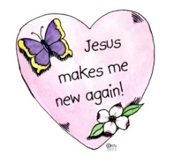
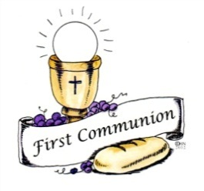
Important Dates
For
First Sacrament Candidates and their Parents

Sun. Sept. 30, 2019 Parent Meeting for First Reconciliation: 6:15 pm at St. Joseph Church

Sat. Jan. 12, 2019 First Reconciliation Retreat at St. Michael Hall 9 am -1:00 pm. At least one parent must attend and bring a bag lunch for your child and yourself.

Wed. Jan. 23, 2019 First Reconciliation in the cluster-Sacred Heart Church at 6:30 pm

Sun. Feb. 27, 2019 Parent Meeting for First Eucharist: 6:15 pm at St. Joseph Church

Sat. March 9, 2019 Chalice Painting (St. Peter Chanel Cafetorium)

Sat. April 27, 2019 First Eucharist Retreat at Sacred Heart Center: 9 am-1:00 pm. At least one parent must attend and bring a bag lunch for your child and yourself.

Sat. & Sun. May 11-12, 2019 First Eucharist Weekend in the Cluster
St. Joseph Sat. May 11, 2019 4:00 pm Mass
St. Joseph Sun. May 12, 2019 9:00 am Mass
St. Michael Sun. May 12, 2019 7:00 am Mass
Sacred Heart Sun. May 12, 2019 11:00 am Mass

