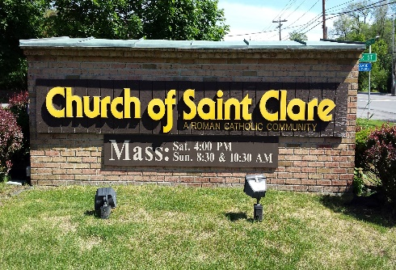  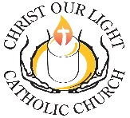 | Faith Formation Registration Form  Church of Saint clare & Christ Our Light Catholic Church  Faith Formation/Youth Ministry Offices  1 Maria Dr. * Loudonville, NY 12211 * Ph. 518 459-6635*  Kari.kurtz@rcda.org  2025 – 2026

Family / Contact Information

Family Name
Primary Mailing Address
Main Home Phone

E-mail Address

Home Parish
 | Parent 1/Guardian Contact Info | Parent 2/Guardian Contact Info

Name
Occupation
Work Phone
Cell Phone
Check if | Guardian, not Parent | Guardian, not Parent
 | Parent does not live with child | Parent does not live with child
Emergency Contacts / Designated Representatives
The persons indicated here should not be one of the parents/guardians listed above.
1 | Name |  | Contact Phone
 | Relationship |  | OK to release child to this person Y N
2 | Name |  | Contact Phone
 | Relationship |  | OK to release child to this person Y N
Dismissal Policy Grade Levels K – 6
All children in levels K-6 will stay in their gathering space after each session until a parent/guardian arrives to sign an attendance sheet with catechist and pick up your child. (Please check the box.)
- I have read the dismissal policy and understand that my child will remain in the building until he/she is signed out by his/her parent/guardian or designated representative.
Youth Volunteers- CHECK BELOW TO HELP:
Greeter (All Ages) | 4 PM Sat. 10 AM Sun. | Lector (5th Grade +) | 4 PM Sat. 10 AM Sun.
Choir (1st Grade +) | 4 PM Sat. 10 AM Sun. | Teen Catechist (7th Grade +) | 5 PM Sun. 6 PM Tues.
Altar Server (4th Grade +) | 4 PM Sat. 10 AM Sun. | Usher (10th Grade +) | 4 PM Sat. 10 AM Sun.
ADULT Volunteers- CHECK BELOW TO HELP: For the safety of our children, all who are with them sign a Code of Conduct, undergo a Background check, and have Safe Environment Training.
K-6 Catechist/Aide | K-6 Sun. K-6 Tues. | Substitute Catechist | K-6 Sun. K-6 Tues. Teens Sun.
Catechist for Teens | 7 – 8 9-10 Confirmation | Gatekeeper | K-6 Sun. K-6 Tues. Teens Sun.

Information (if you have more than 3 children in the program please attach another sheet)
Child #1 | Child's Name |  |  |  |  | My child has celebrated the sacraments of
 | School |  |  |  |  | Baptized First Reconciliation
 | Grade |  | Birth date |  |  | First Communion
 |  |  |  |  |  | I allow any video or photograph of my child taken during a parish function to be used in any parish promotional materials and websites.
 |  | Grades K-6 | Sun.  5 – 6 PM | Tues.  6:00 PM
 |  | Grades 7-Confirmation | Sun.  6:15 – 7:30PM |  |  | MEDICAL: Please list any medical conditions/ allergies
 |  | Are there any accommodations that may assist us in working with your child

Child #2 | Child's Name |  |  |  |  | My child has celebrated the sacraments of
 | School |  |  |  |  | Baptized First Reconciliation
 | Grade |  | Birth date |  |  | First Communion
 |  |  |  |  |  | I allow any video or photograph of my child taken during a parish function to be used in any parish promotional materials and websites.
 |  | Grades K-6 | Sun.  5 – 6 PM | Tues.  6:00 PM
 |  | Grades 7-  Confirmation | Sun.  6:15 – 7:30PM |  |  | MEDICAL: Please list any medical conditions/ allergies
 |  | Are there any accommodations that may assist us in working with your child

Child #3 | Child's Name |  |  |  |  | My child has celebrated the sacraments of
 | School |  |  |  |  | Baptized First Reconciliation
 | Grade |  | Birth date |  |  | First Communion
 |  |  |  |  |  | I allow any video or photograph of my child taken during a parish function to be used in any parish promotional materials and websites.
 |  | Grades K-6 | Sun.  5 – 6 PM | Tues.  6:00 PM
 |  | Grades 7-  Confirmation | Sun.  6:15 – 7:30PM |  |  | MEDICAL: Please list any medical conditions/ allergies
 |  | Are there any accommodations that may assist us in working with your child

Registration Fees and Signature:
If you need to make payment plans or need a scholarship please contact the Faith Formation Office. Make all checks payable to Christ Our Light. Online Payments can be made at https://tinyurl.com/COLFFregistration
Registration form and payment is due by September 1st, 2025. Thank you!
 | 1 child | 2 children | 3 + children |  | Office use only  Payment Status
Registration fee | $45 | $80 | $100 |  | Payment enclosed

Sacraments | 1st Eucharist  & Reconciliation  $35 fee |  | Confirmation  $80 fee |  |  | Office use only
Parent/guardian signature |  |  |  | Date

