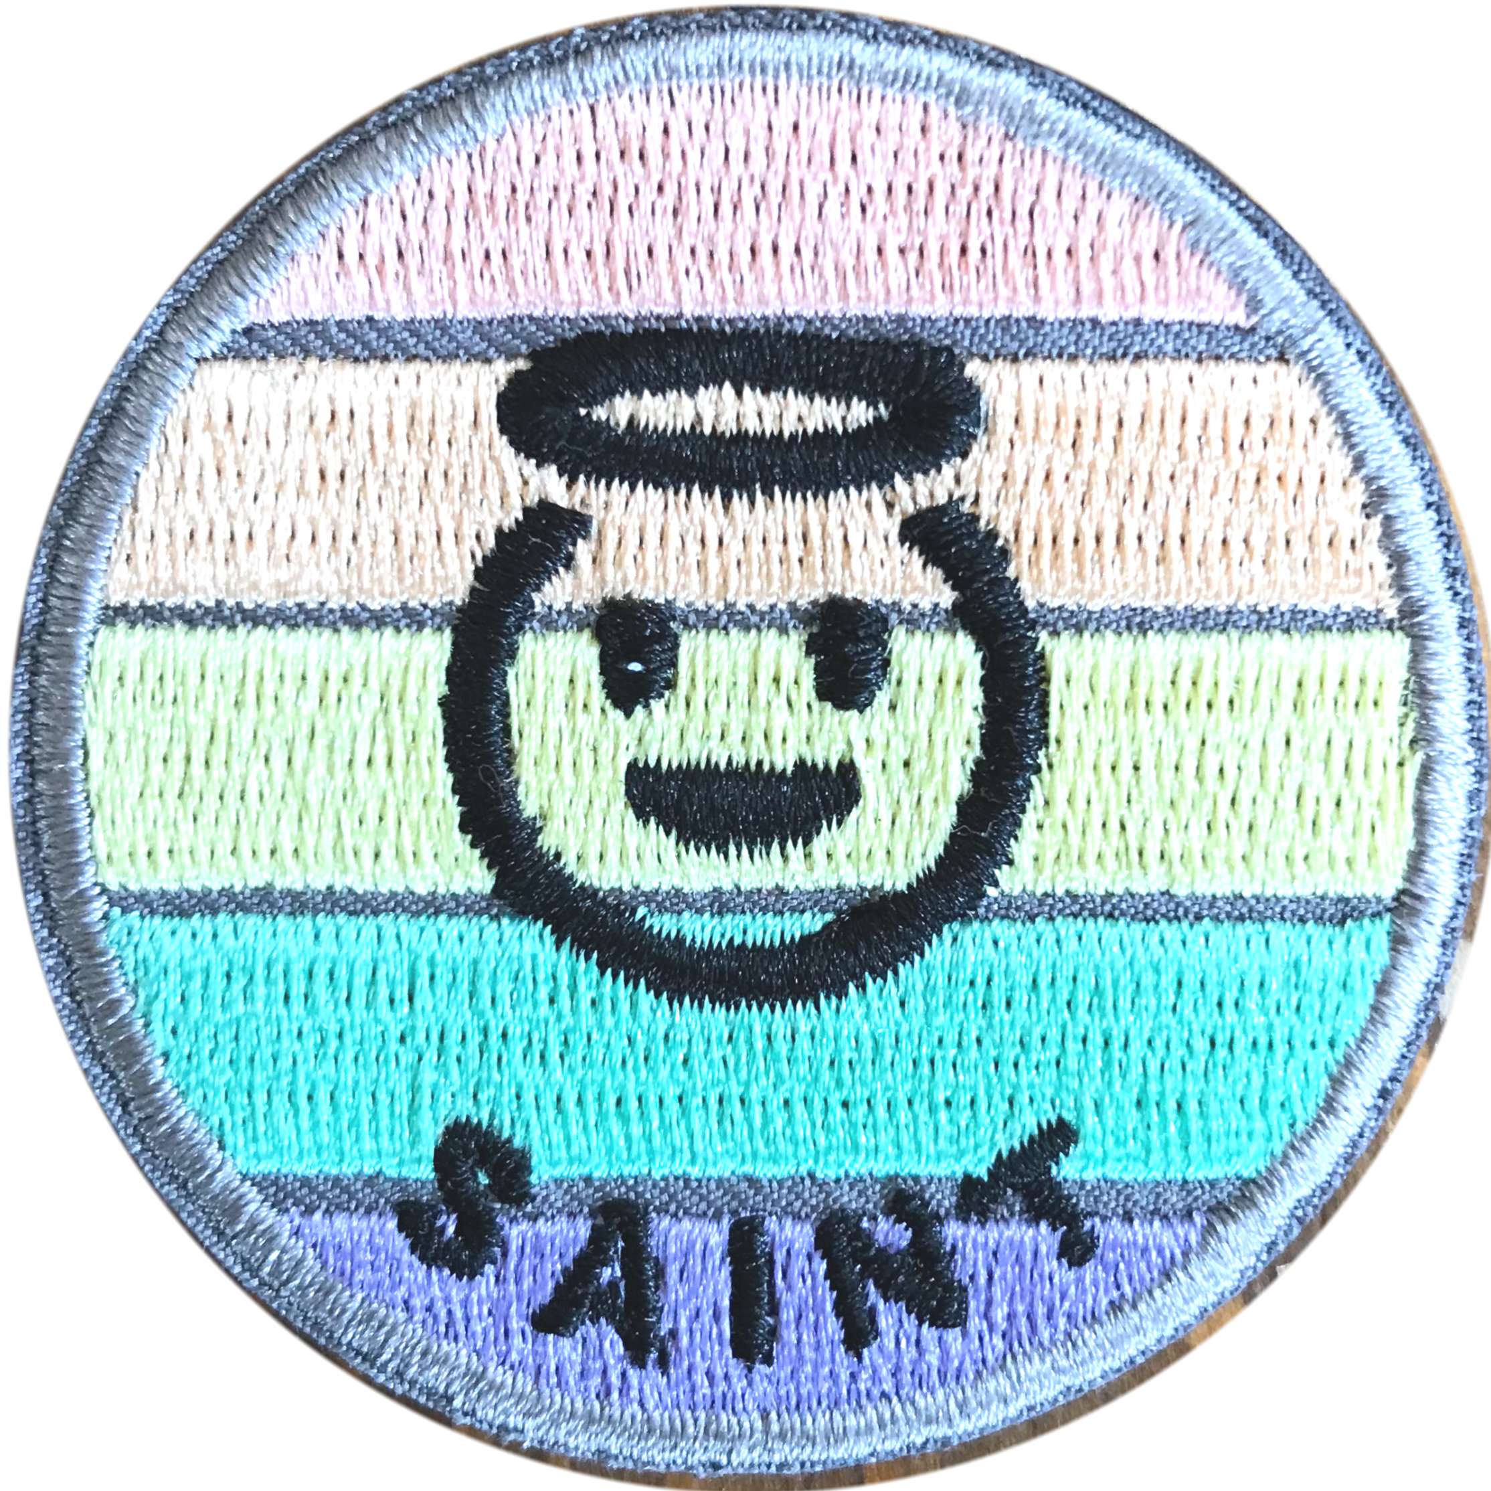
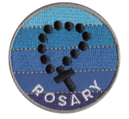
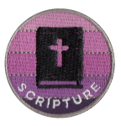
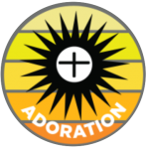
POCO A POCO
Vacation Bible School
Little by little, building habits for holiness

June 21 – 25, 2021/ 9am-12:45p

Please contact Rose Talbot-Babey at rose@drexelcc.org or (239)283-0525 for more information

Fee: $20.00 Per Child ($ 50 Maximum per family)

(Circle One)
Child #1 Name: ______________________________________________ M/F Camper or Volunteer

Date of Birth:________________ Child’s age:_________ Last school grade completed: ____________

Child #2 Name: ______________________________________________ M/F Camper or Volunteer

Date of Birth:________________ Child’s age:_________ Last school grade completed: ____________

Child #3 Name: ______________________________________________ M/F Camper or Volunteer

Date of Birth:________________ Child’s age:_________ Last school grade completed: ____________

Child #4 Name: ______________________________________________ M/F Camper or Volunteer

Date of Birth:________________ Child’s age:_________ Last school grade completed: ____________

Child #5 Name: ______________________________________________ M/F Camper or Volunteer

Date of Birth:________________ Child’s age:_________ Last school grade completed: ____________

Name of parent(s): _________________________________________________________________________

Street Address: _________________________________________________________________

City: ___________________________________State:____________Zip:_____________

Home Phone :(______)______________________________

Parent /caregiver’s cell phone: (_______)________________________________

Home email address: _____________________________________________________

Emergency Information

Allergies or other medical conditions (Please list names with allergies/medical conditions):

____________________________________________________________________________________________

____________________________________________________________________________________________

____________________________________________________________________________________________

Emergency contact, relationship to child & phone number:

Who will pick up/ drop off your child(ren)?: __________________________________________________

Phone Number: ____________________________________

If your child was not enrolled in Faith Formation classes OR Confirmation this year, please complete the Faith Formation packet found on our website at www.drexelcc.org and submit it with this VBS registration form.

Vacation Bible School is from 9am-Noon.
Campers will get a light snack each day but may bring a snack of their choosing if they wish.

Thursday is water day.
ON THURSDAY, please send children in their bathing suits with sunscreen already applied.

We will have a hotdog picnic following the campers’ presentation on Friday. Family is invited to join us during the picnic for $1 per person.

“Let us always greet each other with a smile
for the smile is the beginning of love.”
~Mother Teresa of Calcutta

