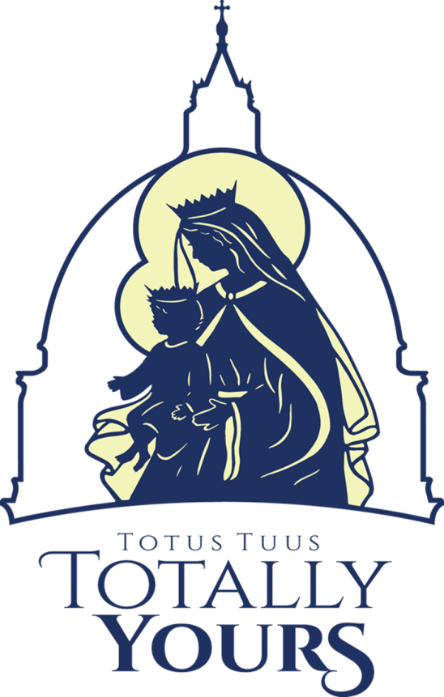
Elementary Program (Incoming 1st-6th Grade)
Teen Program
Students entering grades 7-12 (graduated seniors may also attend)
Sunday-Thursday 7:00-9:00pm
Join us for a week of engaging discussions, prayer opportunities, learning, games, and live changing witnesses of how to give yourself totally to God! Teen program is FREE
Cost:
Register by:
Date: Monday, July 5th

Monday, July 12th-Friday, July 16th

JH and HS Program (Incoming 7th-12th Grade)
Sunday, July 11th-Thursday, July 15th

At Russia Local Schools and St. Remy Church
Summer Youth Program

Questions:
Contact: Mark Travis, St. Remy Church, Director of Youth Ministry
Grade School Program
Students entering grades 1-6
Monday-Friday 9:00am-2:30pm
Join us for a fun, faith-filled day with games, skits, songs, sacraments, class, lunch, & recess
(Bring a snack & sack Lunch)
Cost: $25 per kid, no more than $100 per family.

Faith, Friends, Fellowship, & Fun
Totus Tuus (a Latin phrase meaning “totally yours”) was the motto of Pope St. John Paul II. It signifies our desire to give ourselves entirely to Jesus Christ through the hands of our Blessed Mother Mary.
The mission of Totus Tuus is to inspire in young people a true longing for holiness. Seminarians and college students from the Archdiocese of Cincinnati carry this mission to every young person and participant of Totus Tuus.
The youth see that these young adults are joyful and on fire with the Catholic faith, which encourages them to strive for the same thing in their lives.

