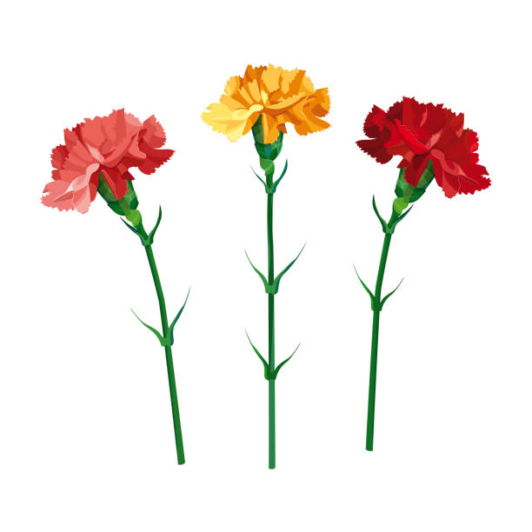Carnations were a visible sign in Memory and Honor of special Fathers on the St. Francis Xavier Altar on Father’s Day Weekend.
In Memory of:
Fr. Robert Ament Terry Anderson Kenneth Bailey
James Barrett Russell Beenken Art Benetti
Jerry Chandler Donald Chapman Vernon Chapman
Fr. Thomas Currier Joe Doyle Richard Eckhoff Harold Fuller (2)
Bill Jurgens John Just Donald Kaiser Joseph Kaiser
Fr. John Karal Keven Ketchum Lynn Knoll Louis Kopriva (2)
John Lager, Sr. Maurice Leonard Ernest Lohse Harold Martinek
Jack McLaughlin James McLaughlin Jerry McLaughlin Joe McLaughlin
Michael P. McLaughlin William (Bill) McLaughlin Tom McMahon Gerald McNulty
James McVey, Jr. (2) James McVey, Sr. Ted Meddlekauff W. J. "Tiny" Merriam
Douglas Nelson Eugene Nelson (2) Rodney Nelson Tanner Pals
Thomas Quigley Merlin Reiland Chris Sloth Gordon Sloth
Lee Smith Leo Smith Jack Spitler John Spitler
Ronald Steenblock Duane Trager Eddie Trager Ray Thompson
Aubrey Waterhouse Douglas Waterhouse

In Honor of:
Christian Anderson Jan Anderson Jeff Anderson Andy Bailey
Chris Bailey Joe Bailey Larry Bailey Bernie Barrett
Cpt. Daniel Barrett Jon Barrett Nick Barrett Father Blake
Cary Brown Lance Chandler Lane Chandler Brett Cooper
Kris Dunkin Christian Fisher Erik Fisher Mark Fisher
Bradford Fletcher Rich Haisman Barry Huedepohl Ralph Huedepohl
Richard Kaiser Mark Ketchum Hubert Kopriva (2) Doug Lohse
Larry Lohse Serapio Lucio John McGrann (2) Joey McLaughlin
Jonathan McLaughlin Mark McLaughlin Paul McLaughlin Tony McLaughlin
Jim McMahon Dennis McNulty Brian McVey Jacob McVey
Nathan McVey Geoff Nelson Greg Nelson Mick Nelson
Scott Nelson Tom Nelson Matt Olson John Pagel
Eugene Quigley Frank Quigley Patrick Quigley Stephen J. Quigley
Thomas (Tommy) Quigley Kyle Rolfes James D. Scheller Dennis Sloth
Ryan Sloth Paul Spitler Dennis Steenblock Todd Steenblock
Kory Swart Sid Swenson Charlie Thielen
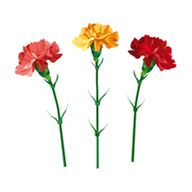
Andy Trager Raymond Trager Ken Umthun

