Assumption of Risk and Waiver of Liability Relating to COVID-19
The novel coronavirus ("COVID-19") has been declared a worldwide pandemic by the World Health Organization. COVID-19 is extremely contagious and is believed to spread mainly from personto-person contact. As a result, federal, state, and local governments and federal and state health agencies recommend social distancing and have, in many locations, prohibited the congregation of groups of people.
St. Mary of the Lakes has put in place preventative measures to reduce the spread of COVID-19; however, we cannot guarantee that you will not become infected with COVID-19. Further, participation
in St. Mary of the Lakes could increase your child(ren)'s or your risk of
contracting COVID-19.
By signing this agreement, I acknowledge the contagious nature of COVID-19 and voluntarily assume the risk that I may be exposed to or infected by COVID-19 by participating in
__________________________ at St. Mary of the Lakes and that such exposure or infection may result in personal injury, illness, permanent disability, and death. I understand that the risk of becoming exposed to or infected by COVID-19 at St. Mary of the Lakes may result from the actions, omissions, or negligence of myself and others, including, but not limited to, employees, volunteers, and program participants and their families.
I voluntarily agree to assume all of the foregoing risks and accept sole responsibility for any injury to myself (including, but not limited to, personal injury, disability, and death), illness, damage, loss, claim, liability, or expense, of any kind, that I may experience or incur in connection with my
participation in at St. Mary of the Lakes. On my behalf, I hereby release,
covenant not to sue, discharge, and hold harmless Parish Name and the Diocese of Orlando, and all of their current, former, and future agents, representatives, religious and employees and related entities (collectively, "the Diocese") of and from the Claims, including all liabilities, claims, actions, damages,
costs or expenses of any kind arising out of or relating thereto. I understand and agree that this release includes any Claims based on the actions, omissions, or negligence of the Diocese, its employees, agents, and representatives, whether a COVID-19 infection occurs before, during or after or participation in
parish activity or event: _________________________________.

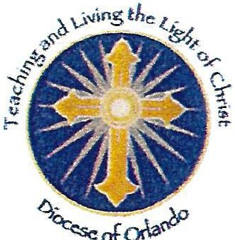
___________________________________

Signature
____________________________________

Printed Name
_____________________________

Date

