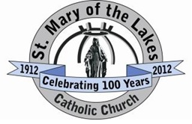
Name: _________________________________________________ Date: ___________________
St. Mary of the Lakes
Confirmation Class (Week of October 19, 2021)

Directions: Watch the video “Community, Part 1 with Ennie Hickman (The Four Marks)” on Formed.org. Use the Formed handout to gain free access to this website, if you have not already done so. Then answer each of the following questions in ONE of the following ways: (1) Print this form and write in the answers. (2) Type your answers on this form and print it when finished. (3) Record a video or audio recording with your answers and email them to faithformation@stmaryofthelakesparish.org.

Please answer the questions in detail and be honest. Keep this form private, as it will only be shared with your parents and our team of catechists in order to better serve you. The answers to the first few questions are in the video you must watch. The last few are personal. God bless.

- What is the Church?
- List the Four Marks of the Church.
- How is the Church “One”?
- How is the Church “Holy”?

- Can we be made saints?
- What does “Catholic” mean?
- How is the Catholic Church “Apostolic”?
- Do you own a Bible and do you read it?
- Do you own a Catechism of the Catholic Church (book)?
- Do you attend Mass every Sunday?

