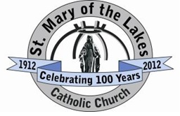
Name: _______________________________________________________________________
St. Mary of the Lakes
Pre-Confirmation Class: Tuesday, October 5, 2021

Chosen: Lesson 1

Directions: After watching today’s video lesson, think about the idea of happiness. Answer the following questions on this sheet (type or handwrite), or on an audio or video recording. If you choose the audio or visual style, email your file to faithformation@stmaryofthelakesparish.org. Due on October 12th, in class.

- What makes you happy?

- What makes other people happy?

- Do you think that God wants you to be happy?

- Who is this God we are talking about? Tell us who God is to you. (Be honest. We’re all human here.)

