The Sacraments, Virtues and Gifts

A sacrament is an outward sign, instituted by Christ to give grace
Sacraments of Christian Initiation
- Baptism
- Confirmation
- Eucharist
Sacraments of Healing
- Penance/Reconciliation
- Anointing of the Sick
Sacraments of Service
- Holy Orders
- Matrimony

The Seven Corporal Works of Mercy
- To feed the hungry To give drink to the thirsty
- To clothe the naked To visit the sick
- To visit those in prison To shelter the homeless
- To bury the dead

The Seven Spiritual Works of Mercy
- To admonish the sinner To instruct the ignorant
- To counsel the doubtful To comfort the sorrowful
- To bear wrongs patiently To forgive all injuries
- To pray for the living and the dead

The Seven Gifts of the Holy Spirit
- Wisdom Understanding
- Knowledge Counsel
- Fortitude Piety or Reverence
- Fear of the Lord or Awe & Wonder

The Twelve Fruits of the Holy Spirit
- Charity Joy
- Peace Patience
- Kindness Goodness
- Long-suffering Humility or Gentleness
- Modesty Fidelity or Faithfulness
- Continence or Self-Control Chastity

The Three Theological Virtues
- Faith Hope Charity

The Four Cardinal Virtues
- Prudence Fortitude
- Justice Temperance

The Seven Capital Sins
- Pride Anger
- Covetousness Lust
- Envy Gluttony
- Sloth

The Four Last Things
- Death Judgment
- Heaven Hell
This is what we believe
Teachings & practices
of the Catholic Church
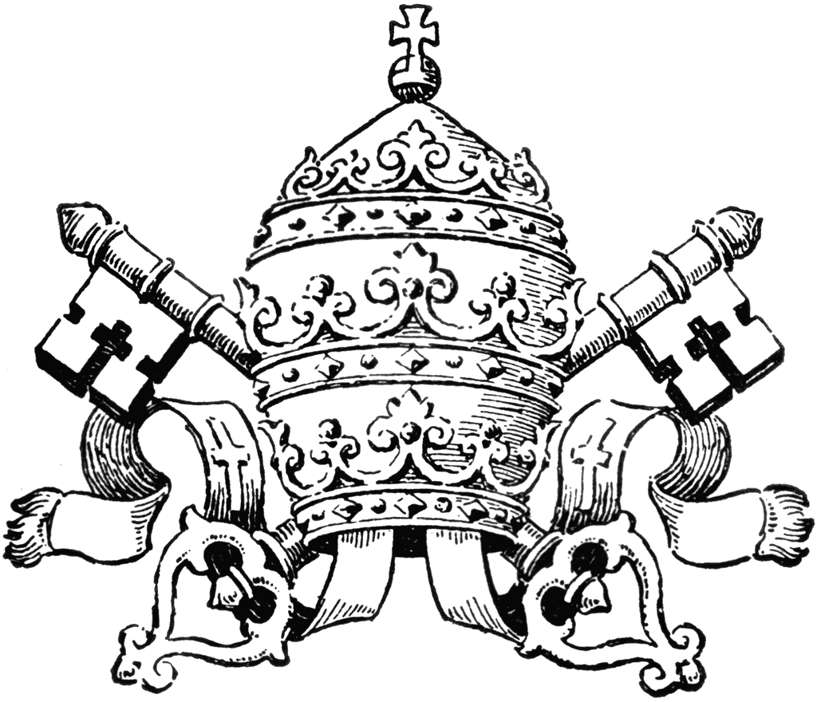
Nicene Creed
I believe in one God, the Father almighty, Maker of heaven and earth, of all things visible and invisible. I believe in one Lord Jesus Christ, the Only Begotten Son of God, born of the Father before all ages. God from God, Light from Light, true God from true God, begotten, not made, consubstantial with the Father; through Him all things were made. For us men and for our salvation He came down from heaven, and by the Holy Spirit was incarnate of the Virgin Mary, and became man. For our sake He was crucified under Pontius Pilate, He suffered death and was buried, and rose again on the third day in accordance with the Scriptures. He ascended into heaven and is seated at the right hand of the Father. He will come again in glory to judge the living and the dead and His kingdom will have no end. I believe in the Holy Spirit, the Lord, the giver of life, who proceeds from the Father and the Son, who with the Father and the Son is adored and glorified, who has spoken through the prophets. I believe in one, holy, catholic and apostolic Church. I confess one Baptism for the forgiveness of sins and I look forward to the resurrection of the dead and the life of the world to come.

The Precepts of the Catholic Church
- To actively participate at Mass on all Sundays and Holy Days of Obligation.
- To receive Holy Communion at least once a year during the Easter season. The Sacrament of Penance should be celebrated at least once a year in Lent, and whenever in the state of serious or mortal sin.
- To study Catholic teaching in preparation for the Sacrament of Confirmation, to be confirmed, and to continue to study and advance the cause of Christ.
- To observe the marriage laws of the Church.
- To do penance on all Fridays and to fast and abstain on the days appointed.
- To contribute to the support of the Church.
- To join in the missionary spirit and apostolate of the Church.

The Great Commandments
Jesus Christ said that the whole Law can be summed up in two commandments:
- You shall love the Lord your God with all your heart, with all your soul, with all your mind, and with all your strength.
- You shall love your neighbor as yourself. (Matt 22:37-39)
The Ten Commandments
- I am the Lord your God, you shall not have strange gods before Me.
- You shall not take the name of the Lord your God in vain.
- Remember to keep holy the Lord’s day.
- Honor your father and your mother.
- You shall not kill
- You shall not commit adultery.
- You shall not steal.
- You shall not bear false witness against your neighbor.
- You shall not covet your neighbor’s wife.
- You shall not covet your neighbor’s goods.

The Beatitudes
- Blessed are the poor in spirit, for theirs is the kingdom of heaven.
- Blessed are they who mourn, for they will be comforted.
- Blessed are the meek, for they will inherit the land.
- Blessed are they who hunger and thirst for righteousness, for they shall be satisfied.
- Blessed are the merciful, for they will be shown mercy.
- Blessed are the clean of heart, for they will see God.
- Blessed are the peacemakers, for they will be called children of God.
- Blessed are they who are persecuted for the sake of righteousness, for theirs is the kingdom of heaven.

Holy Days of Obligation:
- January 1: Mary, Mother of God
- 40 days after Easter: Ascension of the Lord
- August 15: Assumption of the Blessed Virgin Mary
- November 1: All Saints Day
- December 8: Immaculate Conception of Mary
- December 25: Nativity of the Lord

The Liturgical Seasons (and colors)
- Advent (Violet & Rose on third Sunday)
- Christmas (White & Gold)
- Lent (Violet, Rose on 4th Sunday, Red on Palm Sunday)
- Easter Triduum (White & Red on Good Friday)
- Easter Season (White & Gold, Red on Pentecost)
- Ordinary Time (Green)
- Solemnities-Trinity, Corpus Christi, etc. (White)
- Feast Days of Martyrs (Red); Saints (White)

Fasting, Abstinence & Penance (CCC 919, 1434, 1438, 2043)
- Catholics 18-60 must fast on Ash Wednesday & Good Friday. The laws of fast limits the amount of food consumed to one full meal a day. Some food may be eaten at two other times of the day but together should not equal a full meal.
- Catholics 14 years or older must abstain from meat on Ash Wednesday and all Fridays of Lent.
- To receive Holy Communion, one must be in a state of grace, have the right intention, and observe the Eucharistic fast, which is no food or drink for one hour before.
- All Catholics must do some act of penance on all Fridays in remembrance of Christ’s Sacrifice.
Catholic Questions and Answers

God

What is the mystery of the Blessed Trinity? (CCC 253-255)
One God is an eternal community of three Divine “Persons” (Father, Son and Holy Spirit), separate yet fundamentally equal, all of whom have existed and always will exist, who live in a constant exchange of love.

Who is the Father? (CCC 239)
By calling God "Father", the language of faith indicates two main things: that God is the first origin of everything and transcendent authority; and that He is at the same time goodness and loving care for all His children.

Who is Jesus Christ? (CCC 479-483)
At the time appointed by God, the only Son of the Father, the eternal Word, that is, the Word and substantial Image of the Father, became incarnate; without losing His divine nature, [consubstantial with the Father] He has assumed human nature. Jesus Christ is true God and true man, in the unity of his divine person; for this reason, He is the one and only mediator between God and men. Jesus Christ possesses two natures, one divine and the other human, not confused, but united in the one person of God's Son. Christ, being true God and true man, has a human intellect and will, perfectly attuned and subject to His divine intellect and divine will, which He has in common with the Father and the Holy Spirit. The Incarnation is therefore the mystery of the wonderful union of the divine and human natures in the one person of the Word.

Who is the Holy Spirit? (263-264)
The mission of the Holy Spirit, sent by the Father in the name of the Son (Jn 14:26) and by the Son "from the Father" (Jn 15:26), reveals that, with them, the Spirit is one and the same God. "With the Father and the Son he is worshipped and glorified" (Nicene Creed). "The Holy Spirit proceeds from the Father as the first principle and, by the eternal gift of this to the Son, from the communion of both the Father and the Son"

What is the Paschal Mystery? (CCC 571, 1362-1372)
Jesus’ “Passover” from death to Life. By rising from the dead He conquered sin and showed us the promise of eternal Life. His resurrection showed conclusively His authority over death and His divinity.

Christ’s work of redemption accomplished principally by his Passion, death, Resurrection, and glorious Ascension, whereby “dying he destroyed our death, rising he restored our life”. The paschal mystery is celebrated and made present in the liturgy of the Church, and its saving effects are communicated through the sacraments, especially the Eucharist, which renews the paschal sacrifice of Christ as the Sacrifice offered by the Church.
The Mass

What happens at the Sacrifice of the Mass?
- The source and summit of our faith is the Eucharist. The great act of giving thanks to God through Christ and in the Holy Spirit, is the central act of the Catholic faith. The celebration of the Eucharist is the Mass.
- The Faithful gather on all Sundays and Holy Days of Obligation to listen to the Words of God proclaimed in the scriptures and to make present Jesus’ sacrificial death in the way He commended: through the offering of bread and wine.
- The bread and wine are changed into the Body, Blood, Soul and Divinity of Jesus when the priest repeats the words of Consecration spoken at the Last Supper. In this way the sacrifice on the cross that Jesus offered on Calvary is made present again so that we can join in offering it to the Father and receive its benefits.

How is Christ present in the Eucharist? (CCC1373-1375, 1413)
Jesus Christ is present in the Eucharist in a unique and incomparable way. He is present in a true, real and substantial way, with His Body and His Blood, with His Soul, and His Divinity. In the Eucharist therefore, there is present in a sacramental way, that is, under the Eucharistic species of bread and wine, Christ whole and entire, God and man.

Why should I go to Mass every day?
- “The Mass is the most perfect form of prayer!” (Pope Paul V)
- For each Mass we attend with devotion, Our Lord sends a saint to comfort us at death. (Revelation of Christ to St. Gertrude the Great)
- St. Padre Pio, the stigmatic priest, said, “The world could exist more easily without the sun than without the Mass.”
- The Curé d’Ars, St. jean Vianney, said, “If we knew the value of the mass, we would die of joy.”
- Once, St. Teresa was overwhelmed with God’s goodness and asked Our Lord, “How can I thank You?” Our Lord replied, “Attend one Mass.”

Conscience

What is conscience? (CCC 1776-1800)
Conscience is our God-given capacity to understand the law of God written on the heart of every human being. In building our relationship with God, we form our conscience in harmony with the teachings of Christ through the Church and through fervent prayer.
How do we develop a well-informed conscience?
An upright and true moral conscience is formed by education and by assimilating the Word of God and the teaching of the Church. It is supported by the gifts of the Holy Spirit and helped by the advice of wise people. Prayer and an examination of conscience can also greatly assist one’s moral formation.

Confession

What is mortal sin? (CCC 1855,1857)
Mortal sin is a grave infraction of the law of God that destroys the divine life in the soul of the sinner (sanctifying grace), constituting a turn away from God. For a sin to be mortal, three conditions must be present: grave matter, full knowledge, and full consent of the will.

What is venial sin? (CCC 1862)
One commits a venial sin, which is essentially different from a mortal sin, when the matter involved is less serious or, even if it is grave, when full knowledge or complete consent are absent.

What is sacrilege? (CCC 2120)
Sacrilege consists in profaning or treating unworthily the sacraments and other liturgical actions, as well as person, things, or places consecrated to God.

How does one confess their sins?
- Be truly sorry for sin because of offending God (contrition)
- Examine one's conscience
- Confess all mortal sins
- Receive and perform penance
- Say an act of contrition

Heaven, Hell and Purgatory

What is Heaven?
Heaven is where souls live in endless union with God, loving and praising Him and praying for souls not yet in heaven. Only those pure enough to be in God’s presence can be in heaven. Until Jesus died on the cross, heaven was not opened to mankind because of the eternal effects of our sins which would have kept us separated from God.

What is Hell?
Hell is a place for those souls who have chosen to spend eternity separated from God and love. Hell is not a punishment that God inflicts on bad people. Rather, it is an eternal, voluntary choice that can be made if a sinner wants to reject God’s forgiving, merciful love.

What is Purgatory?
Purgatory is a temporary state of purification where souls (after they have died) have the effects of their sins cleansed before they are able to enter heaven. Even though God forgives our sins in the Sacrament of Confession, the temporal punishment of our sin remains and this is what we make up for by spending time in Purgatory. The temporal punishment is the effect of sin that remains on our souls, even after the sin has been forgiven. It’s like a broken window — though the offense is forgiven, the effect remains and has to be fixed.

The Church

What is the Catholic Church?
Jesus instituted the Church by commissioning the twelve Apostles to continue Hs mission of proclaiming the Gospel. All who accept Christ, believe in and live according to the Gospel, profess all that the Church teaches, and are baptized, constitute Christ’s Church which is both visible and spiritual, human and divine, a sign and instrument of the relationship between God and humanity. The Catholic Church preserves and shares all the gifts Christ wants His people to use in order to become holy.

What are the foundations for Catholic Church teachings?
Scripture, Tradition (precepts of the faith continuously transmitted from the Apostolic Church to present day), and the Magisterium (teaching authority of the Church) are so closely united with each other that one of them cannot stand without the others. Working together, each in its own way, under the action of the one Holy Spirit, they all contribute effectively to the salvation of souls. (CCC 95)

What are the four Marks of the Church? (CCC 813-870)
- One: The Church is one because of Her source, foundation, and bonds of unity in Christ.
- Holy: The Church is holy because She is united with Christ, who through the Church sanctifies all people making possible holiness in life.
- Catholic: The Church is catholic in that the Church is universal, She is present to all people in all times and places.
- Apostolic: The Church is apostolic because She can trace Her teaching and authority back to the Apostles and thus to Christ.

Who is the Pope?
The Pope is the successor of St. Peter and the visible head of the entire Church.

What is the infallibility of the Pope? (CCC 2035, 891, 971)
Christ made Peter the first pope and gave him the authority to preserve Christ’s teachings in the Church. Each pope inherits this same mission and authority. When the pope speaks infallibly, he draws upon his authority as Christ’s representative and visible head of the Church on basic matters of faith or morals under the promise of protection by the Holy Spirit.

Prayer

What is prayer?
Prayer is the lifting up of our minds and hearts to God.

Why do we pray?
- To worship God
- To thank Him for His favors
- To obtain from Him the pardon of our sins
- To ask for graces and blessings for ourselves and others
The Stations of the Cross
- Jesus meets the women
- Jesus falls for the 3rd time
- Jesus is stripped
- Jesus is nailed to the cross
- Jesus dies on the cross
- Jesus is taken off the cross
- Jesus is placed in the tomb

- Pilate condemns Jesus to die
- Jesus accepts his cross
- Jesus falls for the 1st time
- Jesus meets his mother
- Simon helps carry the cross
- Veronica wipes Jesus’ face
- Jesus falls for the 2nd time

The Blessed Virgin Mary & the Saints

Devotion to Mary and the Saints? (CCC 956, 971, 2675-79)
Catholics worship only God. Mary is greatly loved and honored by Catholics as the Mother of Jesus. The saints are people who have lived extraordinarily good lives and are models of faithfulness to God. Therefore, Catholics turn to Mary and the saints as intercessors with God. Images, statues and shrines are tangible reminders of Mary and the saints. They remind us of the holy lives of faith and virtue we want to imitate.

What are the three central teachings of our Church about the Blessed Virgin Mary? (CCC 490-493, 966)
- Immaculate Conception: Mary was immaculately conceived. During the normal course of human procreation between Mary’s earthly parents, God the Father kept Mary free from original sin. He accomplished this in anticipation of the merits of Christ on the Cross. The Immaculate Conception is a dogma of the Roman Catholic Church.
- Perpetual Virginity: Mary was a perpetual virgin. To further illustrate that is God’s work that saved us, the fact that Mary remained a virgin after the birth of Jesus was defended by such fathers of the early Church as St. Ambrose, Pope Leo I, and St. Augustine. It was defined by the Church at the second Council of Constantinople in A.D. 553.
- Assumption: Mary was assumed body and soul into Heaven. Finally, the Immaculate Virgin, preserved free from all stain of original sin, when the course of her earthly life was finished, was taken up body and soul into heavenly glory, and exalted by the Lord as Queen over all things, so that she might be the more fully conformed to her Son, the Lord of lords and conqueror of sin and death."506 The Assumption of the Blessed Virgin is a singular participation in her Son's Resurrection and an anticipation of the resurrection of other Christians. Pope Pius XII solemnly defined this doctrine of faith on November 1, 1950. Mary currently enjoys what we all hope to share with Her.

What is the Communion of Saints?
The Communion of Saints is made up of all men who have placed their hope in Christ and belong to him through baptism, whether they have already died or are still alive. Because of Christ we are one Body; we live in a communion that encompasses heaven and earth.

