APRIL: I BELIEVE IN THE HOLY SPIRIT, THE HOLY CATHOLIC CHURCH…
WORKSHEET 1
Opening Prayer: Dear Jesus, thank you for dying, rising, and giving us the Church to guide us to heaven. Help us to be good members of your body, the Church. Amen.
Information:
- Jesus founded the Catholic Church through his life, death, and resurrection.
- He then sent the Holy Spirit, His Spirit, to his disciples on Pentecost.
- Pentecost is the official birthday of the Church.
Bible verses (all are short):
- Matthew 16:13-19 – you are Peter and upon this rock I will build my Church. I will give you the keys to the kingdom. Whatever you bind on earth shall be bound in heaven, and whatever you loose on earth shall be loosed in heaven.
- John 20:23 – whose sins you forgive are forgiven them, and whose sins you retain are retained.
Discussion (make it your own):
- Let us go over the structure of the Church.
  - When Jesus died on the cross and sent His Holy Spirit, he started/founded the Church.
  - Before Jesus went up to heaven, he gave the keys to the kingdom symbolizing the authority of the kingdom to Peter on earth. Therefore, Peter was the leader on earth. Go over the story in Matthew 16:13-19. There have been 266 popes since St. Peter.
  - The other Apostles were there to help Peter, so they became Bishops.
  - There were only 11 other Apostles, so they needed even more help. They recruited men to become priests and help them too.
  - Priests were (and still are) each given a geographical area. Their job is to do their best to bring everyone in that area to heaven!
  - We are all the body of Christ – all of us baptized. The leaders of the Church serve God and us and help us to get closer to Jesus and get to heaven!
- Go through the worksheets. (answer keys for parents are provided)
- As you can see, the Church is still the same structure as it was in the beginning right after Jesus died. Since Jesus started the Church, is still head of the Church, sent his Holy Spirit to guide the Church, and put someone as leader of the Church on earth, we can trust that it is the one true Church. We can also trust the authority of the Church.
- The church isn’t made up of perfect people, besides Jesus and the Holy Spirit. We are sinners, priests are sinners, Bishops are sinners, and even the Pope is a sinner. Some people in the Church have been very, very bad. Even Hitler was a Catholic before he walked away from the Church.
  - This does not make the Church bad. It also doesn’t mean the Church will lead us astray. We can still trust the Church even though people in it are bad because Jesus is still in charge. That doesn’t mean we trust all the priests in their personal opinions. But even the worst Popes never said anything official that changed the Church teaching in a way that went against Jesus. They did things personally that were terrible, but no official Church teaching went against what Jesus wanted. We can trust the Church teaching.
- Go over the Church history timeline. As you can see, this Church we live in now is one and the same Church Jesus founded.
- Analogy
- The Church is a ship going to heaven. Jesus (the captain) set the course for the ship and no one can move the steering wheel. He left, but put the Pope (the first mate) in charge while he was gone. Some people on the ship were evil and mean, and some people jumped overboard because they didn’t like those mean people. Will they get to their destination (heaven)? Would you jump overboard just because some people were mean?
Closing Prayer: Pray the Creed together. Saint______, pray for us!

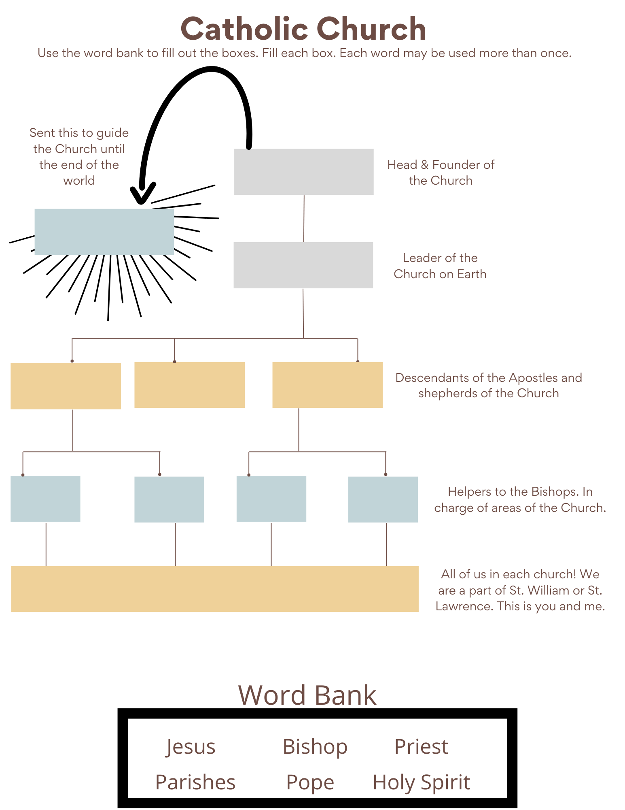

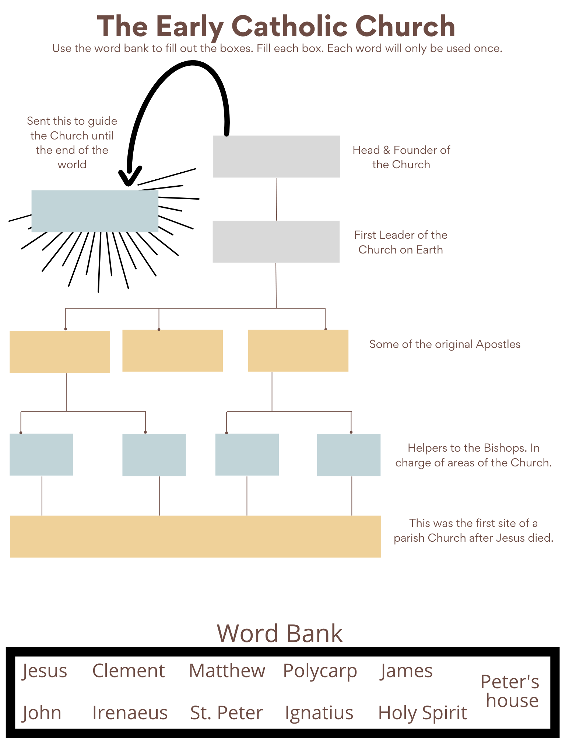
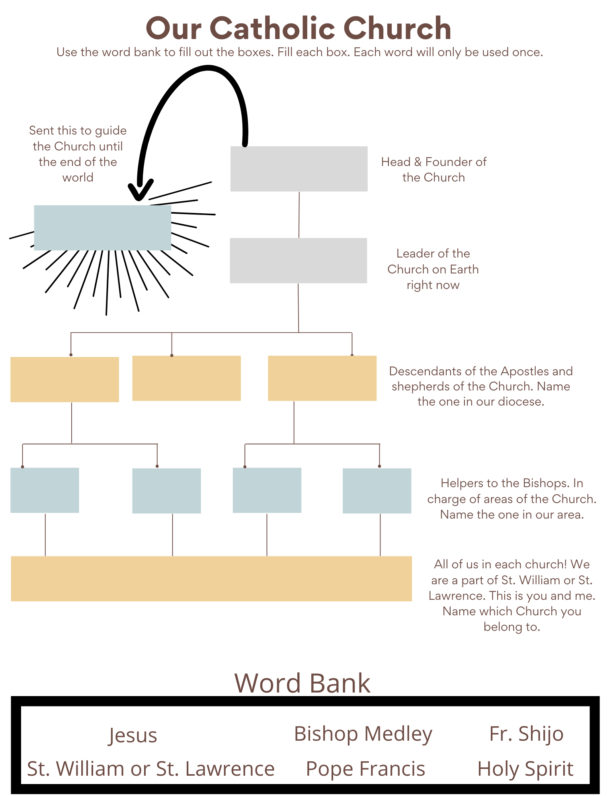
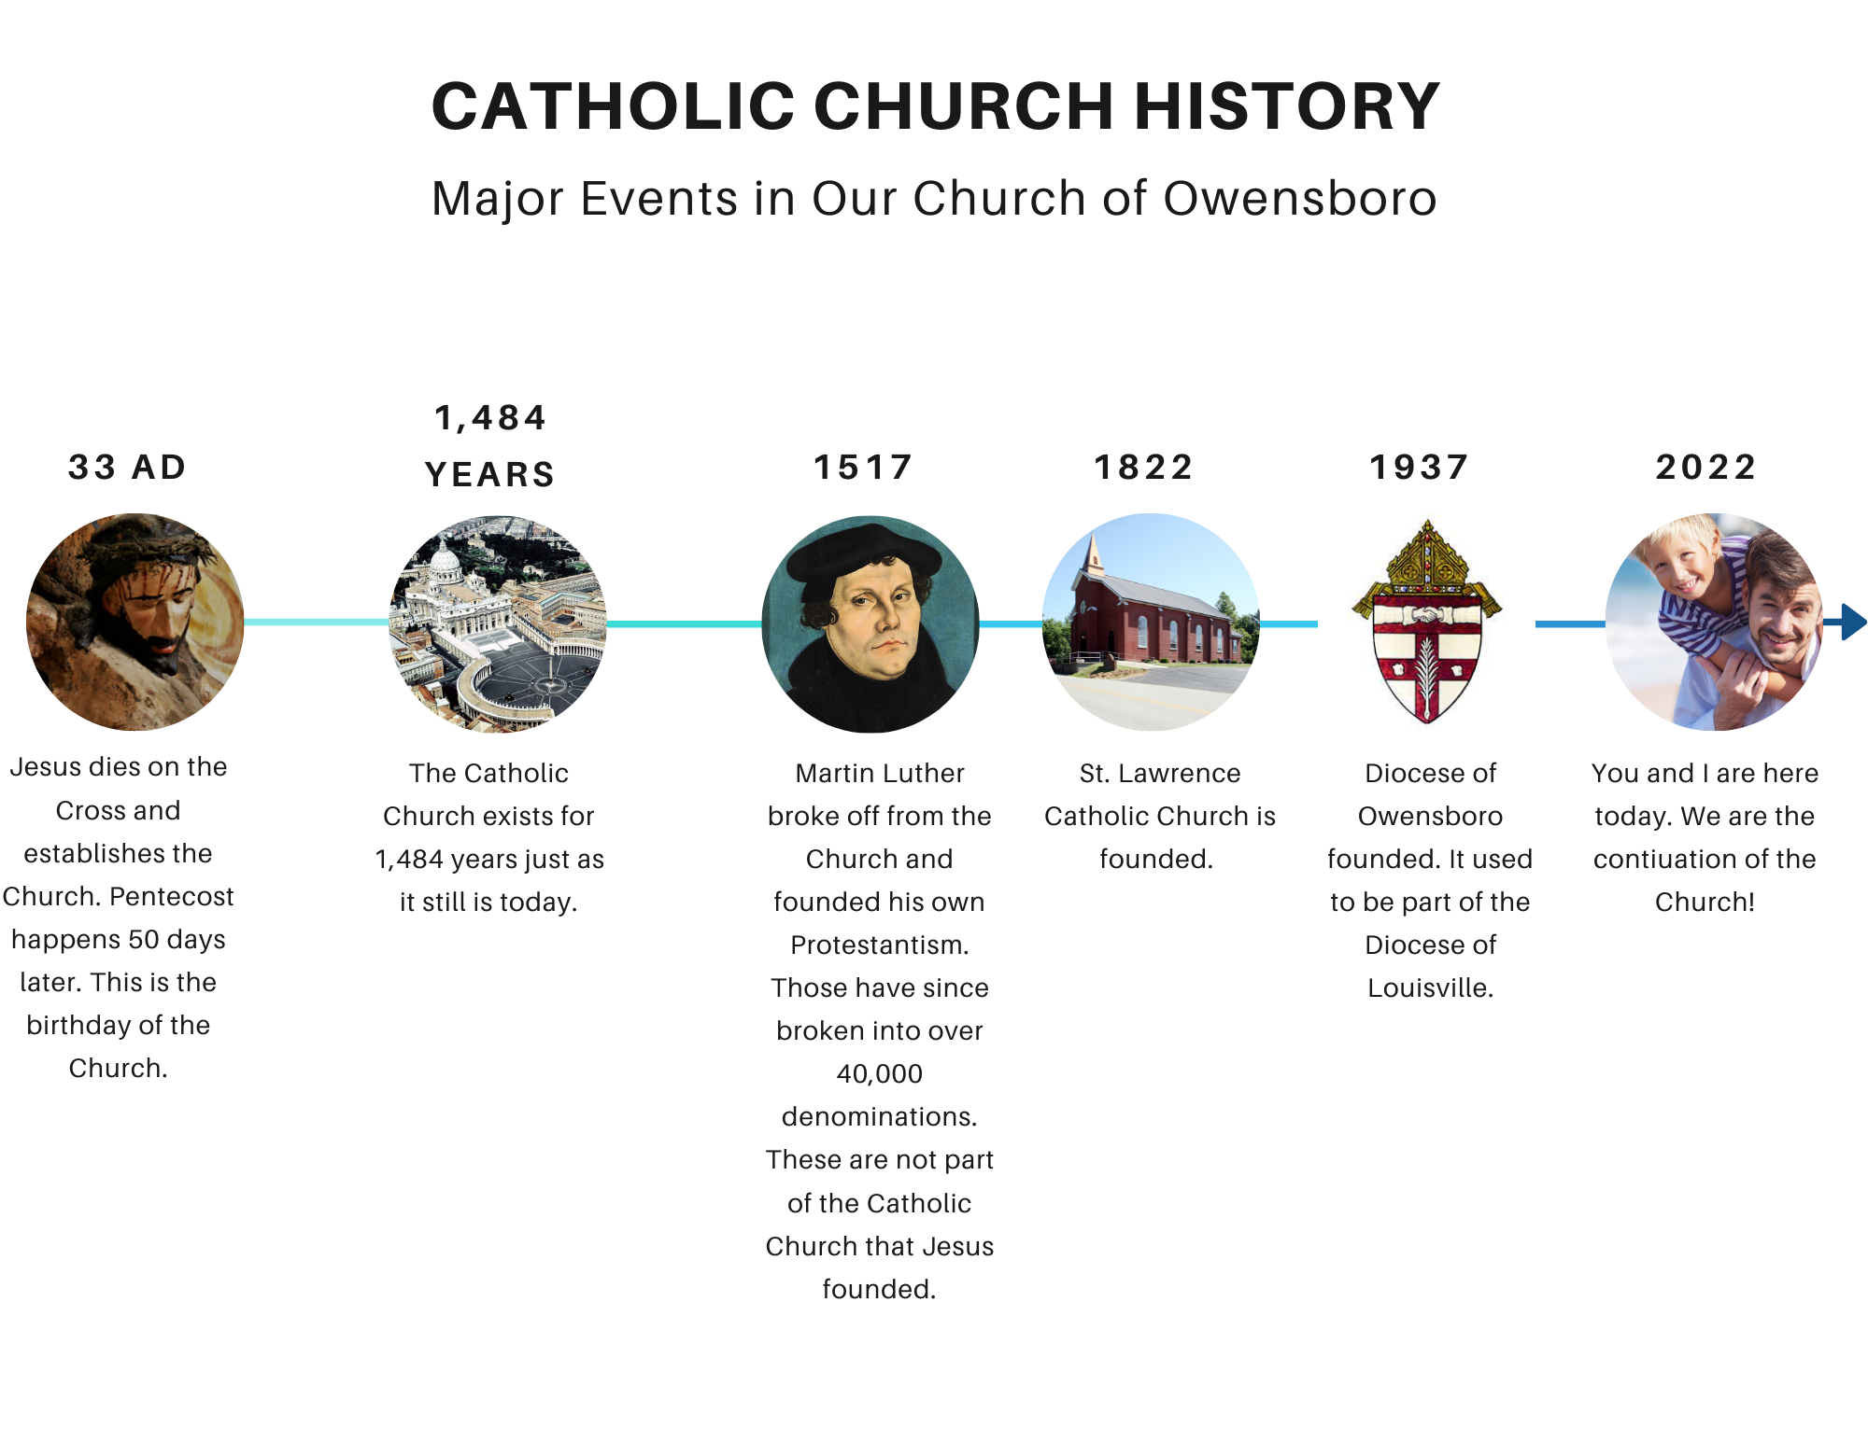
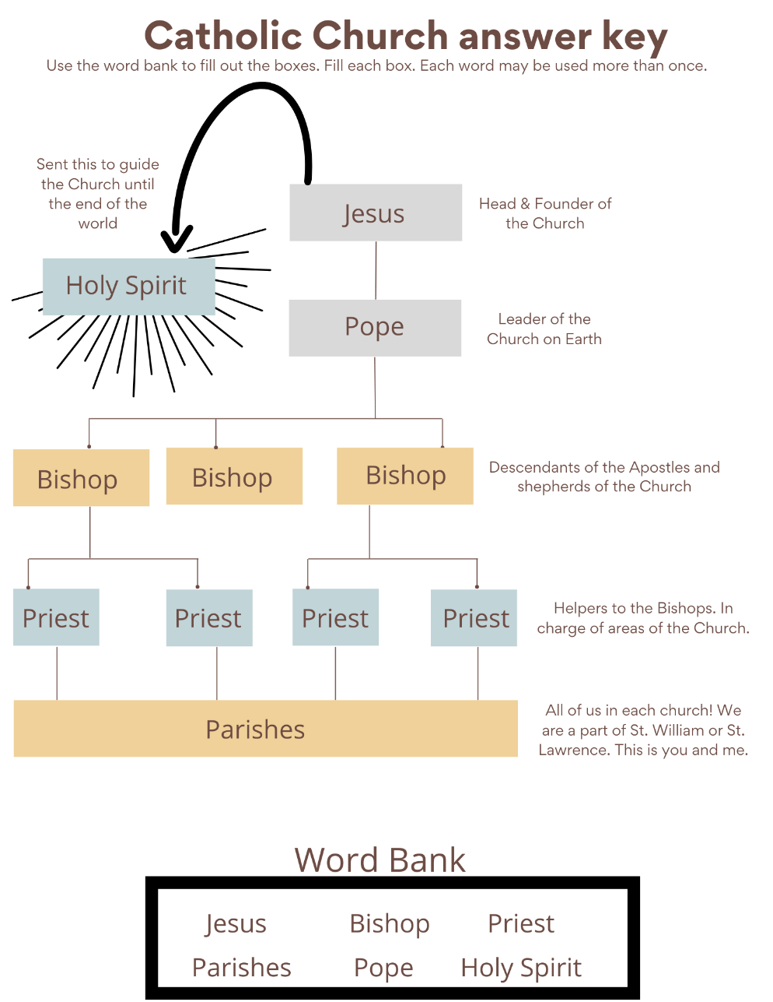
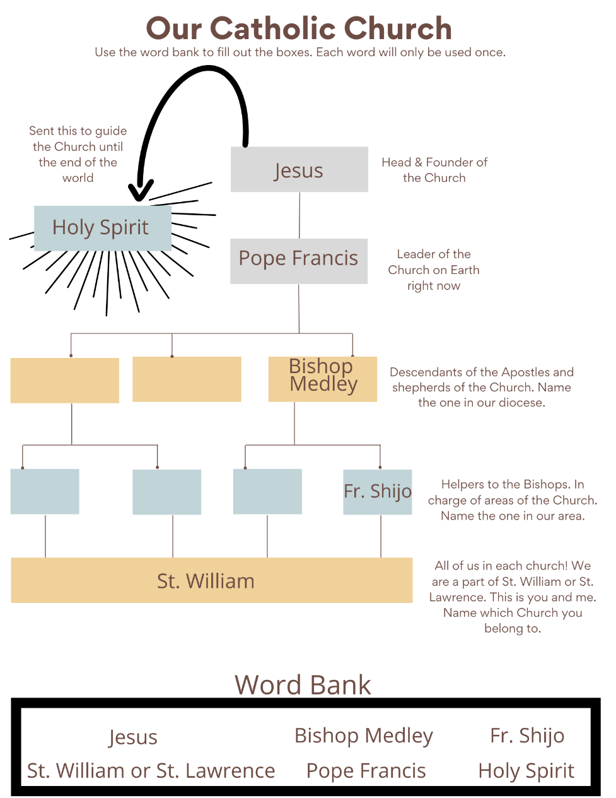
Answer Keys
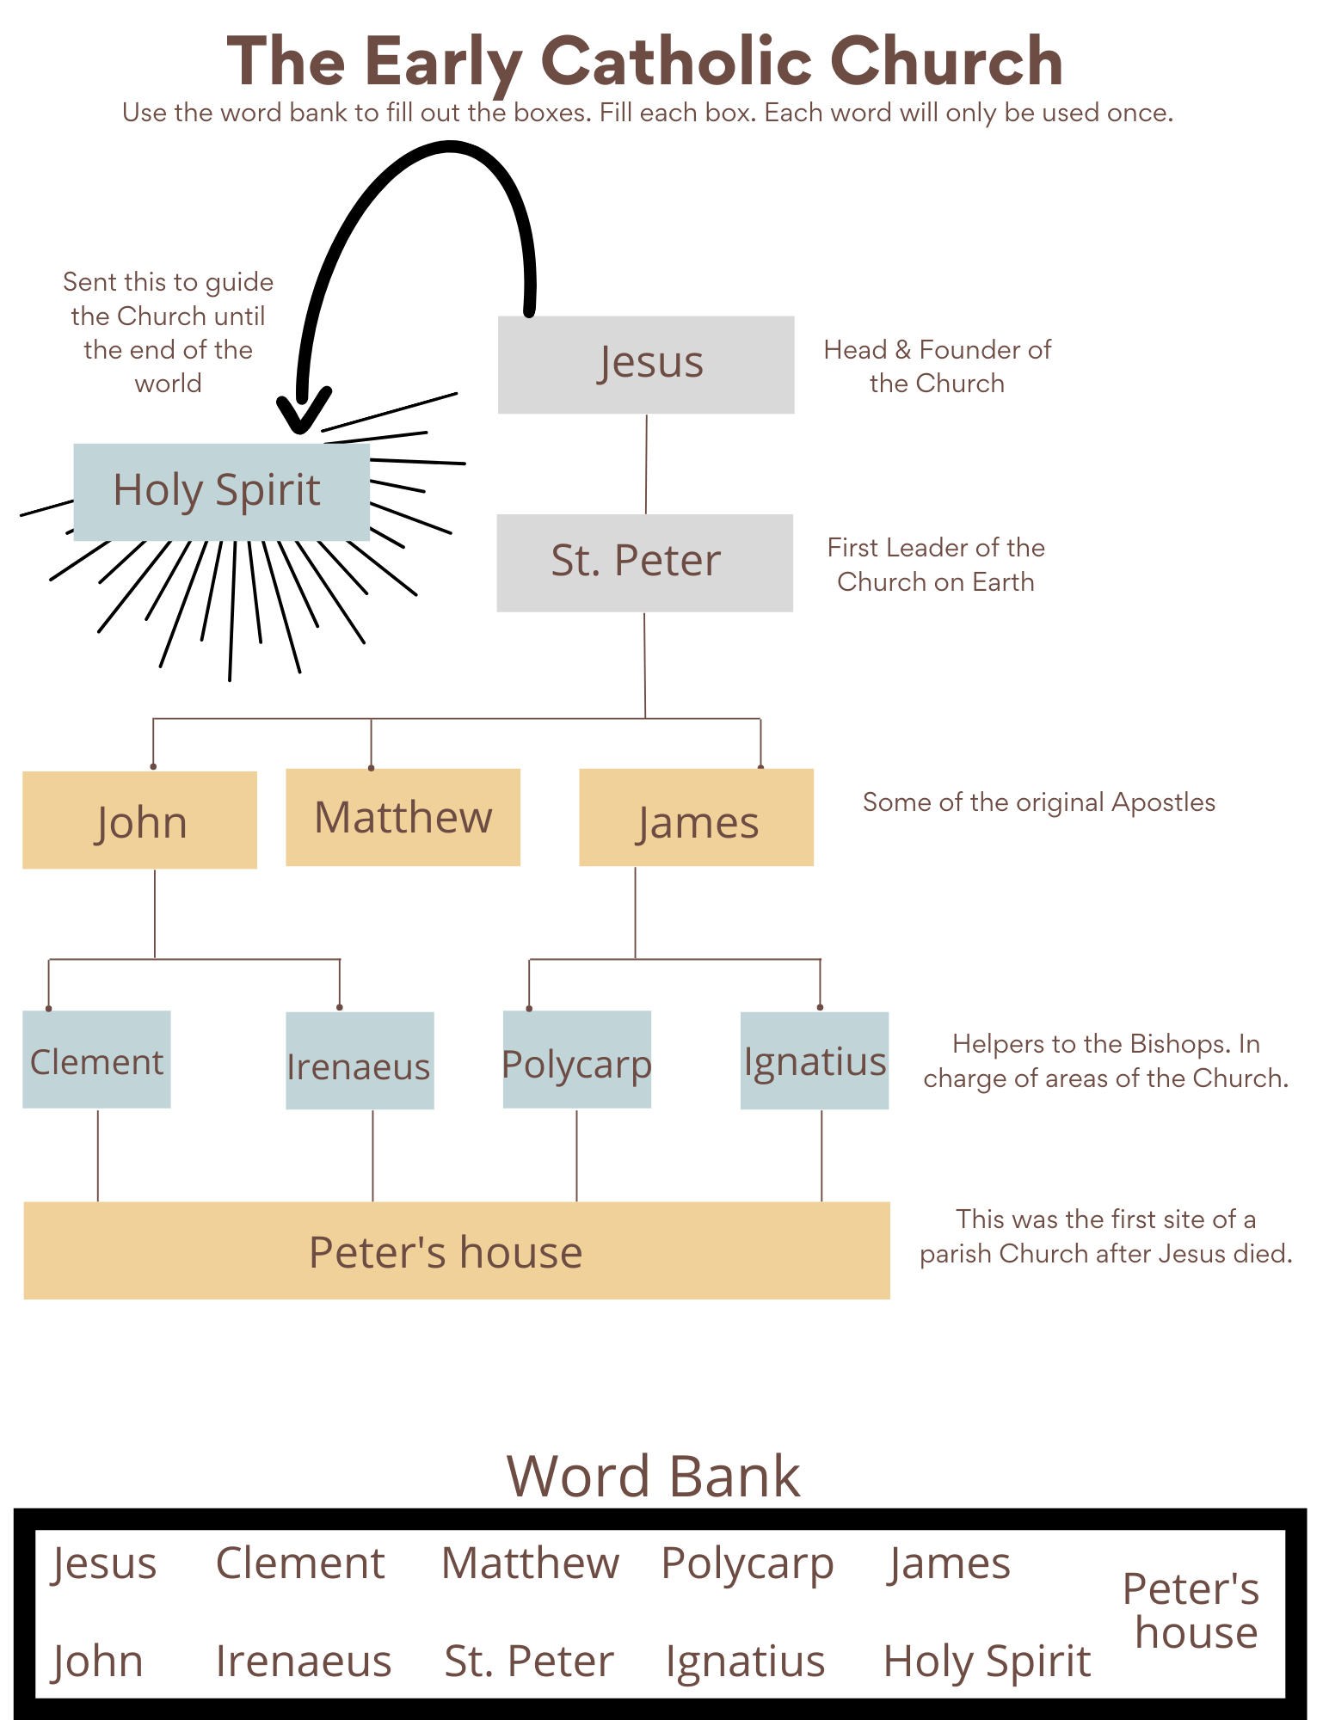
Answer Key

APRIL: I BELIEVE IN THE HOLY SPIRIT, THE HOLY CATHOLIC CHURCH...
WORKSHEET 2
Opening Prayer: Dear God our Father, thank you for giving us your Son, the Holy Spirit, and the Church to guide us. Help us to be faithful and never lose hope of heaven! Amen.
Information:
- The Church has four “marks,” or characteristics that set it apart as the one Church that Jesus Christ founded. We can recognize the Church by these marks.
- The four marks of the Church are one, holy, catholic, and apostolic.

Bible verses:
- John 17:22-23 – that they may be brought to perfection as one
- John 10: 11-16 – I am the good shepherd. A good shepherd lays down his life for his sheep. I know mine and mine know me. I have other sheep that do not belong to this flock, these also I must lead that all may be one.
- Philippians 4:21 – Greet all the holy ones
- Acts 20:28 - Keep watch over yourselves and over the whole flock of which the holy Spirit has appointed you overseers, in which you tend the church of God that he acquired with his own blood.
Discussion points (make it your own and go as in-depth as age permits):
The Four Marks of the Church
One
- Jesus founded one Church.
- What do you one means? What did Jesus intend?
- It is united under the leadership of the one Pope, his representative on earth.
- The Church has one set of beliefs. These are called Dogmas, Doctrines, and Tradition. You can always look up what we believe and find an answer.
- We are all united in one Body of Christ. We all receive the same Eucharist. We are one, and want the whole world to be one with us!
- We must pray for those who are not one with us! We must love them and tell them about Jesus and the Church. After all, don’t we want everyone to be one in heaven with us!
Holy
- The Church is Holy.
- What does Holy mean? What you think it means that the Church is Holy?
- If we follow the Church faithfully, we will learn to be holy.
- The sacraments give us the grace to be holy.
- We who live the teachings of the Church will be holy and enter heaven! That’s one great guarantee!
Catholic
- The Church is catholic.
- What do you think catholic means?
- catholic with a little c means “universal.” This means the Church is for everyone.
- Guess how many Catholics are in the world? There are 7.7 billion people total.
- All over the world, there are 1.34 billion Catholics. That’s over 4 times the amount of people in the United States
- Wherever you go in all the world, you can find a Catholic Church, and it is the same as ours. It may be in a different language with different music, but we all have the same Mass and receive the same Body and Blood of Jesus in the Eucharist.
Apostolic
- The Church is Apostolic.
- What do you think Apostolic means? What other word does is sound like?
- Apostolic comes from the word “apostle.” The Church was run and spread by the 12 apostles.
- Now, the Bishops are the descendants of the apostles and take the role of the apostles. They teach the same faith that the original 12 taught.
You must belong to the Catholic Church to get to heaven.
- This is not because we think we are better.
- This is because heaven is part of the Catholic Church. It’s not just some floating cloud.
- Remember the 3 parts of the Church? – us on earth, people in purgatory, and everyone in heaven!
- How do you gain entrance into the Church?
- Baptism
- Remember the 3 types of baptism?
  - Water-all of us were baptized this way. This is the most common and surest way.
  - Blood-when people are killed for believing in Jesus. They are baptized in their blood. Hopefully this doesn’t happen to many people, but it is a guaranteed way to heaven!
  - Desire -this is the trickiest one. We can’t doubt the mercy of God. Some people that never heard of Jesus but lived a moral life to the best of their ability may have baptism by desire. Or someone that wants to be baptized but dies before the change may have baptism by desire. This is placing everything on a chance, and we can’t tell if someone has baptism by desire. So don’t rely on this one!
Activity for all ages
- See the image below. What do you see? There is a mountain with God at the top and you at the bottom. Our goal in life is to get to God, aka get to heaven. Remember, to do this, we must be part of the Church.
- You may ask, do I have to be Catholic to get to heaven? To answer, let’s remember what we learned.
- Let’s try baptism by desire. Imagine you are a Hindu that’s never really heard of Jesus. You live a good life following all the rules. You are faithful to your wife and family. You are faithful to your job. You are honest, never steal, and try to help everyone that needs it. You may have baptism by desire. Draw a line showing the person walking around the mountain in circles. Around and around and around until you reach the top. Congratulations, you made it to heaven! Was that walk easy?
- Let’s try baptism by water. Say you’re a nondenominational Christian. You’ve been baptized with water. You try to be a good person. You go to Church maybe once a month. You read the Bible also once a month. You try to help others and live according to the rules of the Church. Draw a squiggly line going up the mountain. It has a couple of loops in it where you fell and slid down and had to get up again to keep going. Congratulations, you made it to heaven! Was that walk easy?
- Let’s try another baptism by water. Say you’re a Baptist preacher. You’ve been baptized with water as a baby. You pray an hour every day, read the Bible everyday, go on missions, and serve your community well. You are a good person and help those in need, are faithful to your commitments, and always do the right thing. What kind of line do you think? Try a straight line, a straight shot, right up the mountain. Congratulations, you made it to heaven! Was that walk easy?
- Let’s try a final baptism by water. You are a Catholic, baptized with water as a baby. You live out your faith and go to Mass every Sunday. How do you think you will get to God? Any guesses? Draw an arrow starting out from God and ending at you. At the end of the arrow, draw a circle with a cross in the middle of it. What does that look like? It is a host, the Body and Blood, Soul and Divinity of Jesus that we receive every Sunday at Mass. Did you even have to take a step? No, Jesus comes right down to us. He loves us so much that He comes to us at every Mass physically. We don’t even have to walk! He brings heaven and Himself to us!
- What was the easiest way to get to heaven/God?
- What way will you choose?
Closing Prayer: Pray the Creed together. Saint______, pray for us!
God

