JANUARY: SUFFERED UNDER PONTIUS PILATE, WAS CRUCIFIED, DIED, AND WAS BURIED.
WORKSHEET 1
Opening Prayer: Dear Jesus, thank you for going through all the pain of dying on the cross. Help me to remember how much my sins hurt you and how much you love me. Amen.
Information:
- A walk through the death of Jesus. Many of us know he died for our sins, but don’t understand how much pain and suffering he bore, by choice, for us.
Bible verses:
- Isaiah 52:14 Even as many were amazed at him—so marred were his features, beyond that of mortals, his appearance, beyond that of human beings
- Matthew 27
- Mark 15
- Luke 23
- John 19
Discussion (go over what is age appropriate):
- Let us begin with the agony in the garden. Jesus went with his disciples and took Peter, James, and John away to pray with him. He went a stone’s throw away from them and began to pray to God. He knew what was about to happen, and really didn’t want to go through with it, but prayed that God’s will be done. We believe at this point that Jesus gave up his Godly/Divine knowledge and felt all the emotional and psychological distress to the fullest extent that any human could ever suffer all at one time.
  - Jesus was in so much physical and emotion distress that he began to sweat blood. His sweat glands burst and blood seeped out instead of sweat. Look up what this is called? (Hematidrosis or a variation of spellings)
  - Draw the blood sweat on the face of Jesus.
  - Have you ever had emotional or psychological distress? What kind? Anxiety, depression, fear, sadness, confusion etc. Does it help to know Jesus suffered that too? Why?
- Let us move to the capture and trial of Jesus. He was taken by guards who beat him up and then stuck in prison for the night. He wasn’t given anything to eat or drink and was alone in a cold, dark, dank, prison. Imagine his thirst, his hunger, his sadness as we watched all his friends run away in the garden and leave him all alone.
  - Dehydration also brings a headache and muscle cramps.
  - Do you ever feel like your friends abandon you? How does it make you feel? Have you ever been super thirsty or hungry? It probably was nothing close to what Jesus experienced.
- Now on to the scouring at the pillar. Jesus was hit with a whip with metal balls on the end. He was hit all over with the whips.
  - This caused him to be cut and bruised all over his body, but also caused at least one lung to collapse, and the liver and spleen to be cut. He also had much internal bleeding from this. His body went into early shock, so he also vomited, seized, and fainted on and off.
  - Draw the lashes and cuts on Jesus’ body from the scourging.
  - Have you ever gotten cut, had stiches, scraped your knee, or broken a bone? What was your most painful memory? Imagine how much that hurt you and think about Jesus.
- The crowning of thorns was a ironic torture. The soldiers called Jesus a king in mockery, but he truly is the king of the world. They took a branch of thorns, probably from the Ziziphus spina-christi plant, and forced it on Jesus’ head. This plant has thick thorns up to about 4 inches long.
  - As the crown of thorns was jammed onto his head, it pierced his eyebrows, temples, and skin, scratching against his skull. There are so many nerves in a person’s head that this would have felt like being electrocuted and intense pain was felt all over his head and face. Many say the thorns piercing his temples would have penetrated his brain. Most people would’ve died from the pain, but Jesus was also God, so he didn’t just die, he had to choose when to die.
  - Draw the crown of thorns on Jesus’ head.
  - Have you ever had head pain? A headache, concussion, scratch, or bruise? Can you imagine going through so much pain and choosing to continue? Why would you do that?
- On to the carrying of the cross. Crucifixion was a terrible and torturous way to die. It started in Persia 400 years before Christ, but at that time they just impaled you on a stake, but didn’t hit any vital organs, so you stayed alive for days and died a slow death. The Romans made crucifixion even worse, and saved it only for the worst of criminals. Some Christians are even crucified in other parts of the world for their faith today. It is where the word “excruciating” comes from. Jesus carried the 100 pound cross-beam of his cross across his shoulders and it was tied to his wrists. He fell at least three times.
  - As Jesus should’ve been dead a few hours ago, think of how much will-power it took to carry the cross. Then he fell over and over again. His body barely worked, and the Romans picked Simon of Cyrene to help Jesus carry the cross so he wouldn’t die before getting to the hill.
  - Draw the cross behind Jesus.
  - How much will-power do you have? Do you ever have trouble doing something that you really do not want to do? Ask Jesus for help.
  - Have you ever fallen or failed and it’s been hard get back up and try again? Ask Jesus for help.
  - Think of something you don’t like doing. Simon of Cyrene didn’t want to help Jesus carry his cross at first, but he did and helped Jesus die for our sins. What was a time you were like Simon? Were you glad you did it in the end?
- The crucifixion. Jesus finally made it to the top of the hill, was stripped naked so that all his wounds that were scabbing were re-opened, and was nailed to the cross. Crucifixion requires the person to push against his feet upward in order to breathe. Each breath is very painful. Jesus finally died after 3 hours of suffering for us. He “gave up his spirit,” so he decided when to give up his spirit to God and die.
  - The nails in his hands and feet hits a very sensitive nerve. Every hit your funny bone? It was like that, but constant. His one shoulder was dislocated because they stretched his arms out so wide. Many criminals lasted a few days on the cross, but Jesus was so dehydrated, had lost so much blood, was so beaten, and in so much pain that his brain and body started to shut down. Some say his heart burst because it couldn’t keep up with pumping the little blood he had left. Others say he couldn’t breath enough so he died from suffocating. However the death, he chose when to die, and fully died as his mother Mary watched with great sadness.
  - Draw the nails in Jesus’ hands and feet.
  - Why did Jesus choose to die like this?
  - While Jesus was dying he thought of everyone who would love him back and live a Christian life. He also thought of everyone who would forget about him and reject him and not give him any time. How do you think Jesus felt when thinking about these things?
Activity:
- Pray the stations of the cross. There are many versions online.
- Pray the Holy Face Chaplet. It is very simple and imaginative.
  - Meditate on Jesus’ sense of touch. Think of all the beatings, scratches, and pain. Think of the simple things too. Jesus couldn’t scratch his nose or get the burning sweat out of his eyes. Give him a hug to comfort him.
  - Meditate on Jesus’ sense of hearing. Think of all the mean things that were said to him. Think of everyone yelling and screaming in his ear. He just wanted to hear one kind word. Tell him a kind word.
  - Meditate on Jesus’ sense of sight. Think of all the mean faces he saw. So many strangers and people that hated him. Imagine how bad he just wanted to see one friendly face. Then he only saw fists coming toward him to punch him and hands slapping him. Approach Jesus and let him know you are near. That you are a friendly face that won’t hurt him.
  - Meditate on Jesus’ sense of smell. Think of all the foul smells they shoved in Jesus’ face. The soldiers bad breath yelling at him. They probably pushed his face in the horse poop on the road or stepped on his face with their stinky, dirty feet. How much he wanted the familiar smell of his mom baking cookies or the smell of his grandma’s perfume. Bring him some flowers for him to smell and comfort him.
  - Meditate on Jesus’ sense of taste. Think of how thirsty and hungry he was. Think of all the blood, spit, dirt, and sweat that got into his mouth that he couldn’t rinse out. The soldiers help his mouth open and spat in his mouth. Think of how much he desired just a little water or something to revive him. Bring him a cup of water and tell him that you are there with him.
Closing Prayer: Pray the Creed together. Saint______, pray for us!

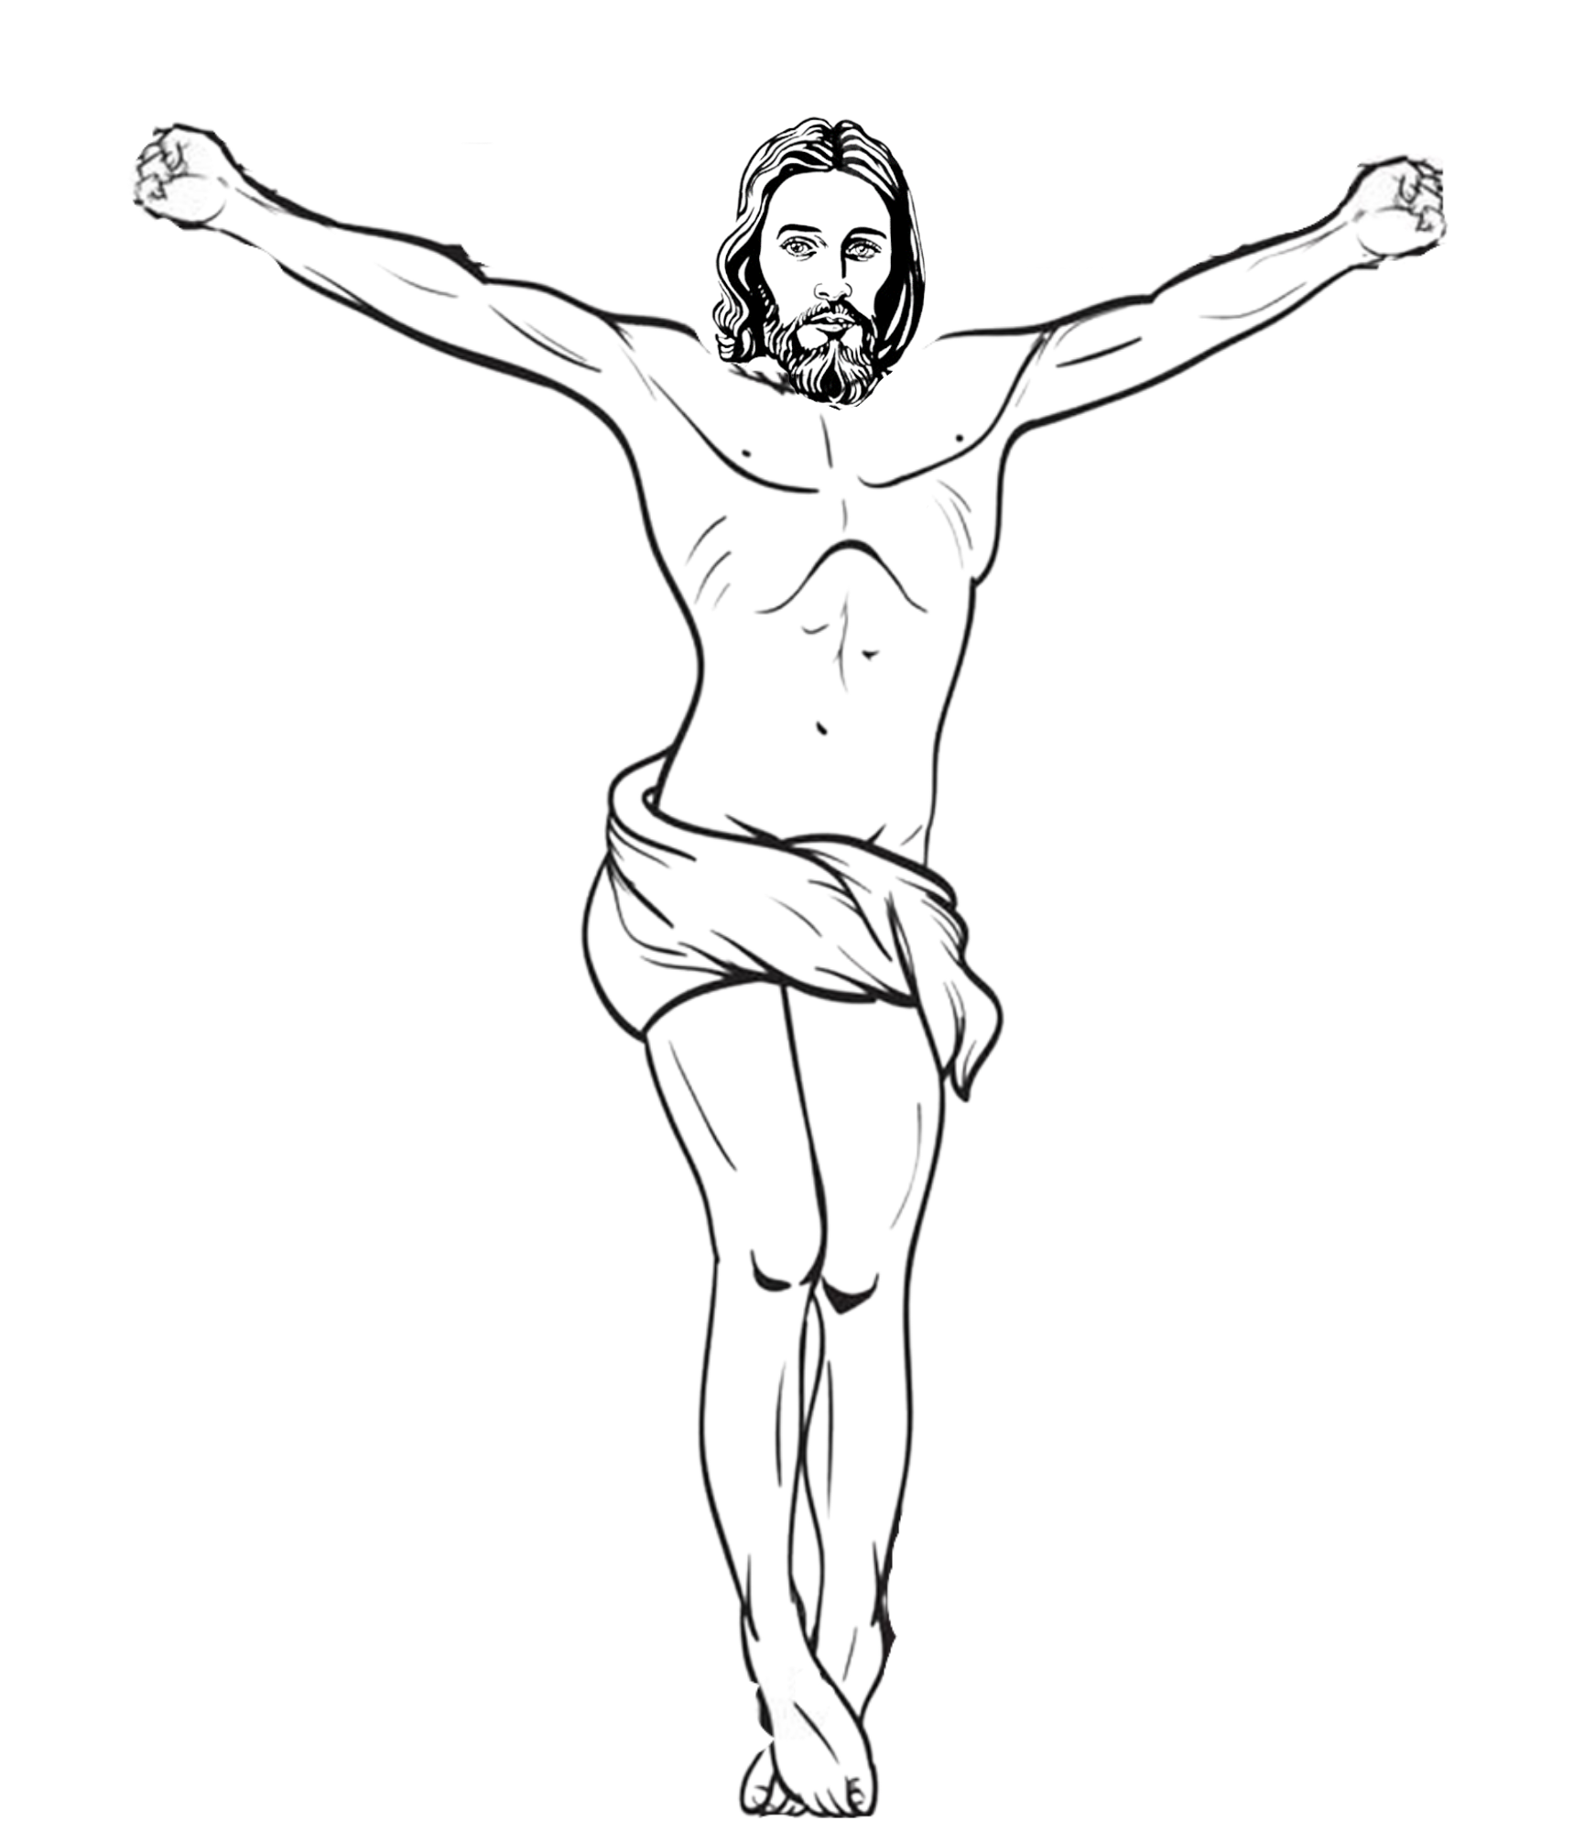

JANUARY: SUFFERED UNDER PONTIUS PILATE, WAS CRUCIFIED, DIED, AND WAS BURIED.
WORKSHEET 2
Opening Prayer: Dear God our Father, thank you for giving up your son Jesus to die on the cross for us. Help me to always repent of my sins and stay close to you. Amen.
Information:
- Jesus died for our sins because he loves us so much. He died for us so we can go to heaven.
- Every day of our life, we have a choice to choose to follow Christ and be a Christian (be obedient to Christ and His Church), or choose to not follow Christ and do what we want instead.
- When we die, our choice is over. We will either go to heaven or hell depending on what we chose at the end of our life.
- There is a saying, “you will die how you live,” so choose wisely. No one knows when you will die besides God.
Bible verses:
- John 10:10: I came so that they might have life and have it more abundantly.
- 2 Corinthians 5:15 He indeed died for all, so that those who live might no longer live for themselves but for him who for their sake died and was raised.
Discussion points (make it your own and go as in-depth as age permits):
- Life can be compared to a ball game. What is your favorite ball team? Do you enjoy watching ball games and going to them? There are two main people at a game: spectators and players.
- Write the characteristics of a spectator
- Write the characteristics of a player
- Which one requires much more work? Which one is a lot harder? Which one has a better reward? Which one do you want to be?
- Draw yourself in the baseball diamond as a player. Also draw yourself in the baseball stands as a spectator.
- In life, we also can be a Christian “fan” of Jesus, being an admirer from a distance who watches and cheers for nice things, but never really plays. We never put in sweaty hard work or sacrifice. There is no reward here. Only potentially eternal punishment in hell. In Matthew 7:21, Jesus tells us “Not everyone who says to me, ‘Lord, Lord,’ will enter the kingdom of heaven, but only the one who does the will of my Father in heaven.” Jesus is telling us the spectators won’t enter the kingdom of heaven, but only the real players.
- Remember the last worksheet and all the excruciating pain and death Jesus endured to save us from our sins and let us into heaven. Now it is our choice to accept that or not. If we don’t accept it, we will be a spectator or not even a fan. If we do accept it, we have to put in the work of being a real player, a real disciple or follower of Jesus.
- Write down ways you can be a real player or disciple of Jesus? Remember, if you want be good at it, it will take blood, sweat, and tears just like being a good athlete.
- Draw yourself on the ball field or in the stands. It is your choice. It is a choice you have to make every day of your life!
Activity:
- Make a decision today about whether to follow Jesus. Write down on a paper your decision and put it in one of your draws to keep for later. It can be as simple as “Jesus, today I choose to follow you every day of my life for the rest of my life. Amen.” Keep your promise.
- 2 Peter 10 Therefore, brothers, be all the more eager to make your call and election firm, for, in doing so, you will never stumble.
Closing Prayer: Pray the Creed together. Saint______, pray for us!

Spectator
Responsibilities before the game:_______________________________________________________________________
__________________________________________________________________________________________________
Action required during the game:_______________________________________________________________________
__________________________________________________________________________________________________
__________________________________________________________________________________________________
__________________________________________________________________________________________________
After the game actions:_______________________________________________________________________________
__________________________________________________________________________________________________
Main goal:_________________________________________________________________________________________
Rewards:___________________________________________________________________________________________

Player
Responsibilities before the game:_______________________________________________________________________
__________________________________________________________________________________________________
Action required during the game:_______________________________________________________________________
__________________________________________________________________________________________________
__________________________________________________________________________________________________
__________________________________________________________________________________________________
After the game actions:_______________________________________________________________________________
__________________________________________________________________________________________________
Main goal:_________________________________________________________________________________________
Rewards:___________________________________________________________________________________________
Ways I can be a good disciple of Jesus
Before Mass:_______________________________________________________________________________________
__________________________________________________________________________________________________
During Mass:_______________________________________________________________________________________
__________________________________________________________________________________________________
After Mass:_________________________________________________________________________________________
__________________________________________________________________________________________________
Every day:
At home:___________________________________________________________________________________________
__________________________________________________________________________________________________
At school: __________________________________________________________________________________________
__________________________________________________________________________________________________
A sin I need to overcome:_____________________________________________________________________________
Ways to help me overcome it:__________________________________________________________________________
A virtue I can grow in:________________________________________________________________________________
Ways to help me grow in that virtue:____________________________________________________________________
How will I train to be the best disciple for Jesus, the MVP of the game, and receive the prize of eternal life in heaven?
__________________________________________________________________________________________________
__________________________________________________________________________________________________
__________________________________________________________________________________________________

