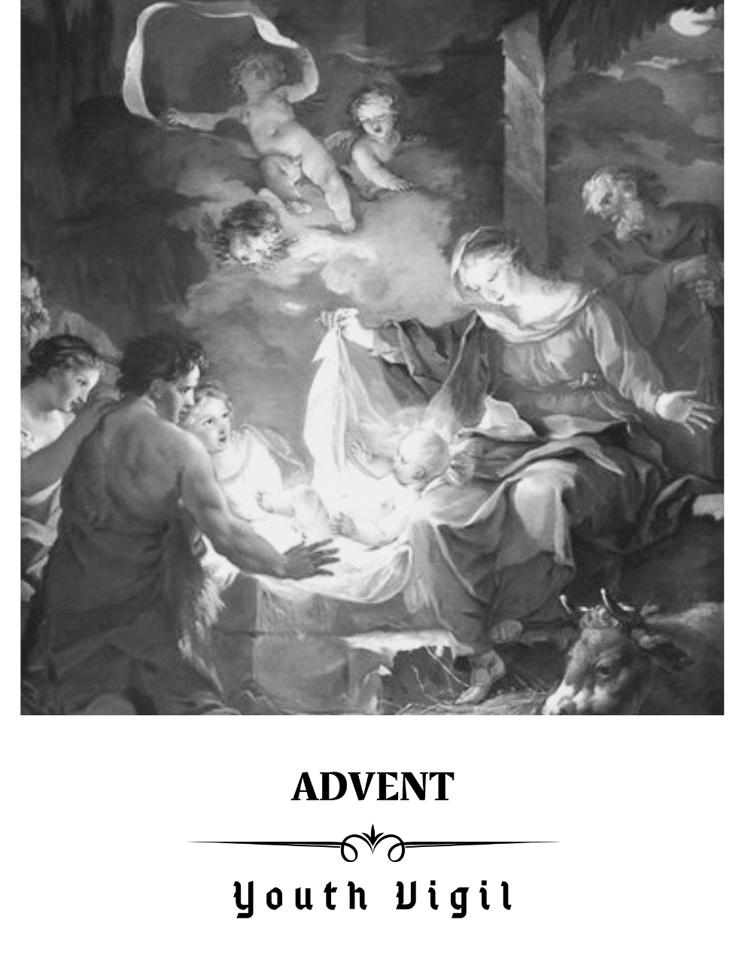
The Angelus
Leader: The angel of the Lord declared unto Mary
People: And she conceived by the Holy Spirit. Hail Mary…
Leader: Behold the handmaid of the Lord
People: Be it done unto me according to thy word. Hail Mary…
Leader: And the Word was made flesh
People: (genuflect) And dwelt among us. Hail Mary…
Leader: Pray for us o Holy Mother of God
People: That we may be made worthy of the promises of Christ.
Leader: Let us pray
All: Pour forth we beseech thee O Lord, thy grace into our hearts. That we to whom the incarnation of Christ thy Son was made known by the message of an angel, may by his Passion and Cross be brought to the glory of his resurrection. Through the same Christ our Lord, Amen.
Opening Hymn Hail Mary, Gentle Woman https://www.youtube.com/watch?v=OUey6ytEXqY
Hail Mary, Gentle Woman
Hail Mary, full of grace,
the Lord is with you.
Blessed are you among women
and blest is the fruit of your womb, Jesus.
Holy Mary, Mother of God,
pray for us sinners now
and at the hour of death.
Amen.
Gentle woman, quiet light,
morning star, so strong and bright,
gentle Mother, peaceful dove,
teach us wisdom; teach us love.
You were chosen by the Father;
you were chosen for the Son.
You were chosen from all women
and for woman, shining one.
Gentle woman, quiet light,
morning star, so strong and bright,
gentle Mother, peaceful dove,
teach us wisdom; teach us love.
Blessed are you among women,
blest in turn all women, too.
Blessed they with peaceful spirits.
Blessed they with gentle hearts.
Gentle woman, quiet light,
morning star, so strong and bright,
gentle Mother, peaceful dove,
teach us wisdom; teach us love.
Procession of Mary with flowers and candles followed by Gospel and candles
Reading 1 Luke: Mary Visits Elizabeth.
During those days Mary set out and traveled to the hill country in haste to a town of Judah, where she entered the house of Zechariah and greeted Elizabeth.
When Elizabeth heard Mary’s greeting, the infant leaped in her womb, and Elizabeth, filled with the holy Spirit,^{s} cried out in a loud voice and said, “Most blessed are you among women, and blessed is the fruit of your womb.^{t} And how does this happen to me, that the mother of my Lord* should come to me? For at the moment the sound of your greeting reached my ears, the infant in my womb leaped for joy. Blessed are you who believed* that what was spoken to you by the Lord would be fulfilled.”
And Mary said:* “My soul proclaims the greatness of the Lord;^{w} my spirit rejoices in God my savior.
For he has looked upon his handmaid’s lowliness; behold, from now on will all ages call me blessed.
The Mighty One has done great things for me, and holy is his name.^{z}
His mercy is from age to age to those who fear him.ª
He has shown might with his arm, dispersed the arrogant of mind and heart.^{b}
He has thrown down the rulers from their thrones but lifted up the lowly.^{c}
The hungry he has filled with good things; the rich he has sent away empty.^{d}
He has helped Israel his servant, remembering his mercy,^{e}
according to his promise to our fathers, to Abraham and to his descendants forever.”^{f}
Mary remained with her about three months and then returned to her home.

Reflection
Mary welcomed Jesus into her body and her heart. She created a nice space for him and made him the center of her life. Do you do the same? What kind of place does Jesus have in your life? Have you made him a nice place? The Mary went and took Jesus inside of her to her cousin Elizabeth. Do you take Jesus with you everywhere? To your sports, school, and friends?

Reflection Hymn Holy is His Name https://www.youtube.com/watch?v=cMVxEfsNKZY&feature=emb_logo
Lyrics
My soul is filled with joy
As I sing to God my saviour:
You have looked upon your servant,
You have visited your people.
Chorus:
And holy is your name
Through all generations!
Everlasting is your mercy
To the people you have chosen,
And holy is your name.
I am lowly as a child,
But I know from this day forward
That my name will be remembered,
For all will call me blessed.
I proclaim the pow’r of God,
You do marvels for your servants;
Though you scatter the proud-hearted
And destroy the might of princes.
To the hungry you give food,
send the rich away empty.
In your mercy you are mindful
of the people you have chosen.
In your love you now fulfill
What you promised to your people.
I will praise you, Lord, my saviour,
Everlasting is your mercy.

We now will set up a place for Jesus in our Church. As we set a place for Jesus here, think about the place for Jesus you are preparing in your heart.
Procession of the Cave
Jesus was born in a cave. Caves are made of solid rock and stand strong for Jesus. The cave stands for courage. Do you have the courage stand strong for Jesus? Do what is right even when no one else is? Do you have the courage to go to Church when no one else wants to?
Priest: Let us pray…
All: Jesus, help me to be a strong rock of faith. Please help me have the courage to always do what is right, no matter what. Help me to be holy. Amen.
Procession of the Manger
Jesus was laid in a manger. Mangers are empty wooden containers that animal’s food is put in. The manger stands for how open our hearts are to God. We must empty our hearts of all the bad. We must make sure there is space open for God to be put in. Do you make space for God in your heart? Do you spend time with Him during the day? Does Jesus take up the most space in your life?
Priest: Let us pray…
All: Jesus, help me to receive you like this manger receives you. Empty me of everything bad. Please help me to always fill my time and myself with things that bring me closer to you. Amen.
Procession of the Straw
Jesus was laid on top of straw. This made it softer for him to sleep on. The straw stands for all our good actions and love. Whenever we do something nice for another, we add straw to the crib. How soft is your crib for Jesus? Is there a lot of straw, or just a little straw? What can you do to add more straw to the crib?
Priest: Let us pray…
All: Jesus, help me to make a soft place in my heart for you. Please help me to only do good things that bring love to the world. Help me to love God and my neighbor. Amen.
Procession of the Star
Jesus under a big, bright star in the sky. The star points the way to Jesus. Just like the star, we also should point the way to Jesus. After Mary received Jesus inside of herself, she also went out and took Jesus to her cousin, Elizabeth. Do we point the way to Jesus? Do we bring Jesus to other people? We need to remember to always be right next to Jesus and shine very bright so other people can also find Him.
Priest: Let us pray…
All: Jesus, help me be a bright star in a dark world. Help me to bring the love of You to everyone I meet. Please use me to bring other people closer to You. Amen.
Priest’s Blessing
Let us pray…
Almighty ever-living God, as we see how the Nativity of your Son according to the flesh draws near, we pray that to us, your unworthy servants, mercy may flow from your Word, who chose to become flesh of the Virgin Mary and establish among us his dwelling, Jesus Christ our Lord. Who lives and reigns with you in the unity of the Holy Spirit, one God, for ever and ever. Amen.
May Almighty God Bless you, In the name of the Father, and the Son, and the Holy Spirit. Amen.
Closing Hymn Sing of Mary https://www.youtube.com/watch?v=thrvsM5KfVI&feature=emb_logo
Sing of Mary, Pure and Lowly
Sing of Mary, pure and lowly,
Virgin Mother undefiled.
Sing of God's own Son most holy,
who became her little child.
Fairest child of fairest Mother,
God the Lord who came to earth,
Word made flesh, our very brother,
takes our nature by his birth.
Sing of Jesus, son of Mary,
in the home at Nazareth.
Toil and labour cannot weary
love enduring unto death.
Constant was the love he gave her,
though he went forth from her side,
forth to preach, and heal, and suffer,
till on Calvary he died.
Sing of Mary, sing of Jesus,
holy Mother's holier son.
From his throne in heav'n he sees us,
thither calls us ev'ry one,
where he welcomes home his Mother
to a place at his right hand,
there his faithful servants gather,
there the crowned victors stand.
Joyful Mother, full of gladness,
in your arms your Lord was borne.
Mournful Mother, full of sadness,
all your heart with pain was torn.
Glorious Mother, now rewarded
with a crown at Jesus' hand,
age to age your name recorded
shall be blest in every land.
Glory be to God the Father;
glory be to God the Son;
glory be to God the Spirit;
glory to the Three in One.
From the heart of blessed Mary,
from all saints the song ascends,
and the Church the strain re-echoes
unto earth's remotest ends.

