St. Lawrence Church Scavenger Hunt
Try to find all these signs, tell what they mean, and answer any questions.
1.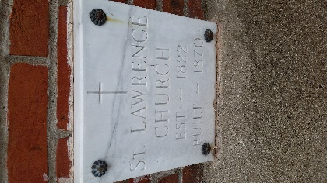 What does this mean? What is a cornerstone?
2. 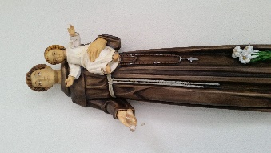 What Saint is this? Why is he dressed in a brown habit? Why is he holding Jesus?
3. What is this? What does it remind us of?
4. 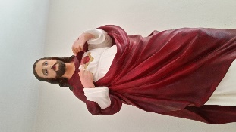What is this a statue of? Why is he pointing to his heart?
5. 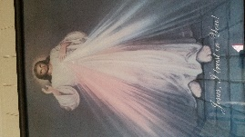What kind of picture is this? Why is there a red and blue stream coming from His heart?
6. 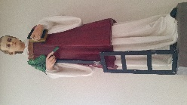 What saint is this? Why is he holding a palm branch?
7. 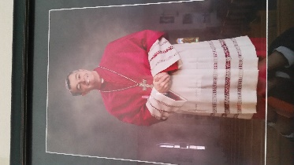 Who is this? Why is he wearing purple/magenta?
8. Who is this? Why do we have a picture of him in the Church?
9. 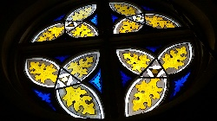 How many leaves do these designs have? Why?
10. 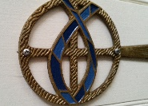 What is this symbol? In the early Church, what was it used for?
11. What type of cross is this? Why is there a circle around it? How many can you find?
12. 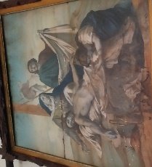 What is this? How many are there? What do we do with them?
13. 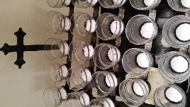 What are these? What do we do with them?
14. 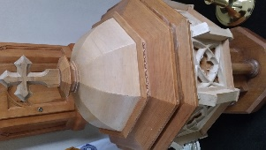 What is this?
15. 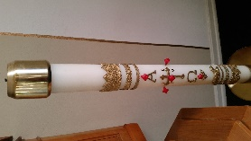 What is this and what does it symbolize?
16. 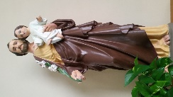 What saint is this and why is he holding lilies?
17. 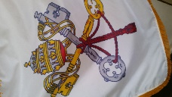What is this? What do the keys symbolize?
18. What is this? What does it tell us?
19. 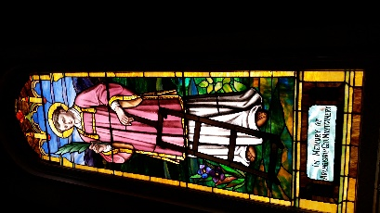 What saint is this? Why is he holding an iron grill?
20. Sometimes we hear signs too. What do these mean when we hear them?
21. Whose home is this? Inside, this is not just a sign.
22. 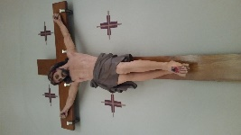 What is this a sign of?
23. 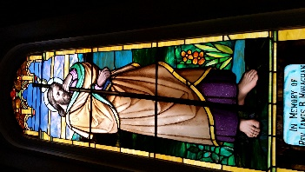What saint is this? Why does he have a shell and staff?
24. Who is this?
25. What are these? Why are there 3 of them?
26. 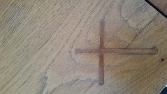 Can you find these? How many are there?
27. What does this sign mean?
28. What are these? How many can you find? What are they called individually?
29. What does this sign mean?
30. Who is this? Why is there a sword in her heart?
31. What is this? What do we put in there? Why?
32. 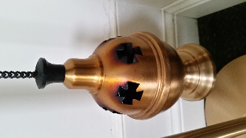 Signs also come in smells. What is this? Why do we use it?
33. What is this? What does it remind us of?

