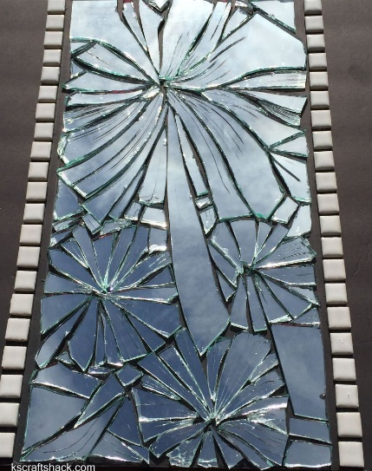
The Broken Mirror
Once upon a time there was a young married couple that had just bought a house. As they were decorating the house, the husband was in charge of hanging everything up on the walls. They had a big mirror that he hung up right over the fireplace, but he had never hung a mirror up before, so he didn’t know what to do exactly, but it was hanging so he left it there. Suddenly, in the middle of the night, he was startled awake by a loud “BANG, CRASH!” He rushed out to see what had happened and there he saw it. The mirror had fallen to the floor and was completely shattered. His wife came to see what happened and saw her husband sadly picking up all the pieces. He apologized over and over again that he didn’t hang the mirror right and it broke. But his wife was a caring woman and said, “don’t worry, something beautiful will come out of this mess.” The next day, the husband went back to throw all the pieces away, but found his wife had already taken them. He thought she threw them away, but a few months later she called him into the garage where she showed him the mirror. He was amazed and started crying. The woman had taken all the broken pieces and put them back together in the form of beautiful flower. The woman said, “see, because this mirror was broken, it became something even more beautiful than if it had never been broken in the first place.” Together they took the mirror and hung it very sturdily over the fireplace and it never fell again. But even if it did, the man knew something even more beautiful would come out of it.
Point of the Story
Our lives are like the mirror. We are baptized and are pure and innocent like the mirror. But soon we start sinning. The sins add up, and we break like the mirror. We can choose to just throw away our pieces, throw away ourselves, but that’s not good. What we should do is take our broken pieces, our sins, to God, and he will put us back together in an even more beautiful way than before. That is what confession is. Confession is bringing ourselves, our broken mirror, to God, Him forgiving us, and letting Him make something beautiful out of us. Grace is like the glue that holds the mirror back together. We can get grace through Confessions, Mass, and prayer. When we sin again, it is like we are breaking pieces off of ourselves again. The more often we go to Confession, the less of mess we will be! A good goal is to go to Confession once a month. You can go every week if you like!

