Yellowcreek Park Sign Scavenger Hunt - Back of Park
Find the signs listed below and take a picture with you and the sign. Answer the questions as to what each sign means.
1. What does this sign mean?
2. What does this sign tell us?
3. What does this sign mean?
4. What does this sign warn us about?
5. What does 27’ x 27’ symbolize?
6. What is this a sign of?
7. What information does this sign give us?
8. 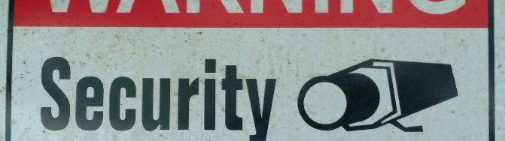 What does this sign tell us?
9. What does this sign mean?
10. What does this sign mean?
11. How does this sign help us?
12. What does this sign tell us?
13. What information does this sign give us?

Answer Key:
Note: to win you can set a time limit and whoever gets the most in the allotted time wins. Or you can do whoever finishes first wins. Depending on your age group, you can use the front half of the park, the back half (probably better for younger kids), or both. Maybe start half the group at #1 and half at #20. All of these signs are near the pioneer village.

1. Bathrooms to the back right. Women’s and men’s and handicap accessible
2. Practice social distancing, stay 6 feet apart
3. Attention, park protected
4. Warning! You can be shocked or electrocuted. Live wires, do not touch.
5. 27 feet by 27 feet
6. America! An older American flag.
7. Blacksmith’s workshop, built in 2012.
8. You are on security camera
9. Which directions the different trails go. Yellow trail to the left, blue, green, and red to the right.
10. Trail detour to the left. Go to the left to go around the fallen bridge on the trail
11. It keeps us from falling where the bridge fell
12. We are on the blue trail
13. This bridge was built in 1897 by the Wrought Iron Bridge Co. Builders

