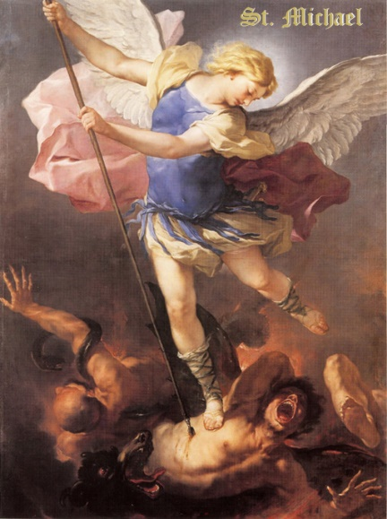
Angels & Demons
This week we celebrate the feast of the Archangels, St. Michael, St. Raphael, and St. Gabriel. We also celebrate the memorial of all guardian angels. To properly celebrate, let us explore the world of the angels. Angels are purely spiritual beings. They have no bodies, but can manifest themselves to humans with some sort of bodies. Throughout the Bible, they are received with fear, since they are such glorious beings, but each visitation ends in peace. Demons can do similar since they are fallen angels, but their visits always end in fear, anxiety, or disquiet. The job of angels varies on their choir. There are 9 choirs of angels divided into 3 triads. The 1st triad’s job is to contemplate and adore God directly. In the 1st traid are: Seraphim, meaning burning ones, are attendants at the Throne of God. They praise God singing, “Holy, Holy, Holy is the Lord of Hosts.” Cherubim, meaning fullness of wisdom, contemplate God’s providence and protect sacred spaces. Thrones represent the steadfastness of God. They contemplate God’s power and judgement. The 2nd triad’s job is to fulfill God’s plan in the universe. In the 2nd triad are: Dominions lord over the lower choirs and humanity. They take illumination from the higher hierarchies and govern the universe. Virtues run the operation of movement in the universe. They are associated with planets, elements, seasons, and nature. Powers assist in governing the natural order. They are warrior angels tasked with fighting the war against demonic choirs. The 3rd triad’s job is to interact with and serve humanity. In the 3rd triad are: Principalities care and guard communities, kingdoms, states, and parishes. They are associated with transitions in power. Archangels communicate and carry out God’s important plans for man. We know three by name—Gabriel, the messenger, Raphael, the healer, and Michael, the defender. Angels are the lowest choir, closest to the material world and humanity. Most of our guardian angels are these type. One thing to remember is demons and the devil are fallen angels. God gave all angels the decision to follow Him or follow themselves, similar to the choice he give us every day. However, since angels are outside of time, this was a one time decision for eternity. Satan used to be Lucifer, or the light-bearer. He was the highest angel of the seraphim choir and closest to God. He could not bear the thought of God becoming man, being born of the Virgin Mary, and dying in order to save lowly mankind, so he rebelled and convinced other angels to rebel too. It is said their battle cry was, “we will not serve.” St. Michael the archangel, the second lowest choir of angels, defeated Lucifer and sent him down to hell. Even though Lucifer was way more powerful, St. Michael could defeat him because God was on his side. So, Lucifer became Satan, the father of lies, and all the other rebels became demons. It is said the Pope gets St. Michael as his extra guardian angel. We also all have guardian angels. Their job is to do all they can to get us to heaven. Guardian angels are assigned at conception, and typically reassigned when their person dies. We have angels and demons swarming around us all the time! How often we forget that! Our world is like a river. We don’t see anything in the water, but we know there is so much life in there! We don’t see the angels and demons, but we know they are there! The angels fight and support us to keep us strong and protected. There are even special angels for different positions or jobs we hold in life. All you angels of God, pray for us!

